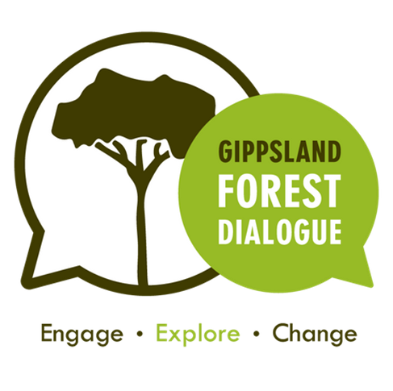
Scoping document
Fire in the forest
Knob Reserve Stratford
Saturday 22nd August

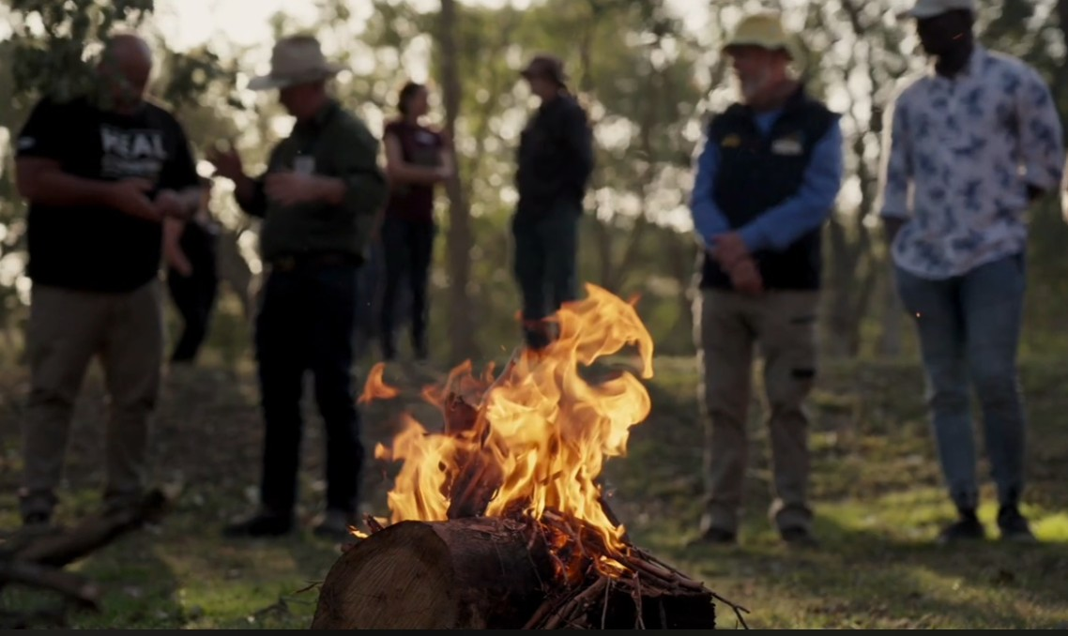

“Fire in the forest”

We would like to thank Wellington Shire for their support of this dialogue
Via their community grants program
Section | Heading | Content | Page
Introduction |  |  | 3
 | Why Fire? |  | 3
 | Co-Chairs |  | 5
 | Where and when |  | 6
Dialogue agenda |  | Saturday 22nd August | 7
Dialogue process |  |  | 9
 | What to expect |  | 9
 | What we expect |  | 9
 | Dialogue model |  | 10
 | Scoping statement |  | 11
Background |  |  | 12
 | Recent fire history |  | 12
 | Victoria’s Bushfire Management Strategy |  | 13
 | Findings of recent Inquiries |  | 17
 | Field trip reports | Noojee | 20
 |  | Bairnsdale | 24
 | Fire is natural |  | 30
 | Fire is dangerous |  | 34
 | Fire is useful |  | 41
 | Fire is changing |  | 57
Emerging trends | Global drivers |  | 63
 | Use of fire |  | 64
 | Wildfire control |  | 66
 | Community and governance |  | 68
Conclusion | Creating a vision |  | 70
 | Opportunities for dialogue |  | 72
 | Further reading |  | 72
 | GFD get involved |  | 72

Introduction
Welcome to the Knob Reserve Fire in the Forest dialogue, the seventh dialogue event run by Gippsland Forest Dialogue over the past 4 years.
Each dialogue we conduct covers a theme of forest management relevant to Gippsland and the future of our forests.
Previous dialogues have considered themes such as recreation (Heyfield), plantations (Yarram), forest health (Orbost) and where to next following the cessation of native timber harvesting in our forest (Kalimna).

Why fire?
South-eastern Australia is acknowledged as one of the most fire prone environments in the world and fire has played an integral role in shaping this landscape. How we manage fire will also be an important fact in the legacy handed to future generations.
Over the past 25 years we have seen a significant increase in the size and intensity of fires and the subsequent impact on the environment and communities of Gippsland. There has also been continued debate as to how we use fire in the environment. For these reasons, fire was identified as a major theme for investigation by Gippsland Fire Dialogue in its initial gathering at Rawson in 2022
At Rawson the conversation covered the following insights, concerns and knowledge gaps.

Key insights
The opportunity to move from a suppression and asset protection culture to a more holistic approach
The science of risk reduction benefits of landscape level burning is contested
Decentralising and localising fire management,
Involving communities in fire management decision making
Effective application of fire for multiple values
Supporting Indigenous groups in their reconnection to country
Improving communication between authorities and communities

Key concerns
The state of Gippsland’s forests given recent large intense fires.
A change in forest structure, more dense regrowth
Climate change driving more intense and frequent fires
Politics and social pressures drive fire management as opposed science
Research community divided on the best approaches
Need to define what a healthy forest is so you can consider fires role
Top down, one size fits all nature of fire management
Knowledge gaps
The absence of indigenous voices or knowledge in fire management
Current best practice fire management is contested and more data or research is needed
Ways to consider multiple values and trade-offs in fire management decision making.

Whilst it was acknowledged the conversation at Rawson was simply an initial scoping session; there was a desire from the Rawson event, for GFD to revisit and explore fire and its role in forests in more depth. This dialogue at the Knob Reserve is the start of that conversation.

This dialogue will introduce this very complex theme, and draw on insights from the field trips conducted a fortnight prior to the dialogue.
The dialogue will look at what fire and fire management means to different stakeholders and communities, and work to find actionable recommendations to achieve balanced outcomes. The starting point for the dialogue will be recent enquiries and their recommendations, and 4 key propositions to test and explore.
The Propositions are:
- Fire is natural
- Fire is dangerous
- Fire is useful
- Fire is changing

Co-chairs and dialogue facilitators
Jess Reeves
Jess is an Associate Professor at Federation University and a member of the Steering committee of Gippsland Forest Dialogue. Jess recently joined the Gunaikurnai Traditional Owner Land Management Board, which oversees the joint management plans for PV/GLAWAC managed parks in Gippsland including the Knob Reserve.
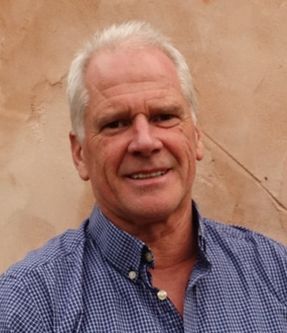
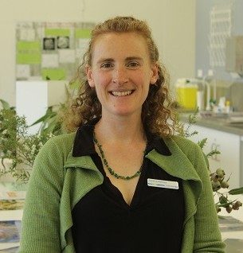
Steve Pascoe
Steve Pascoe is passionate about community led approaches to bushfire preparedness and disaster recovery.
He has been involved in emergency management for over 35 years, firstly volunteering with CFA and VICSES, then working as a community educator in bushfire safety, as an emergency management coordinator in local government, and as a disaster management consultant working with local, state and national governments.

In 2009, Steve’s community of Strathewen was devastated by the Black Saturday bushfires. 80 out of 100 houses were destroyed (including Steve’s), along with the school and community hall. 29 people died. Steve was one of a small group of Strathewen elders who initiated the Strathewen Community Recovery Association and was Deputy Chair of the association for 2 years.

Steve led the development of a community-based approach to bushfire fuel management for the protection of townships, and in 2019 helped facilitate the application of this approach in Mallacoota. Following the 2019/2020 bushfires, Steve was flown into Mallacoota to help facilitate the development of a community led recovery association to lead their community’s recovery.

Steve is now volunteering as a Disaster Recovery Mentor, helping community leaders and recovery practitioners around Australia navigate the challenges of community recovery after disasters.

Where and when
The fire in the forest dialogue will take place at the Knob Reserve in Stratford, on Saturday 22nd August. It will be preceded by a series of field trips which will occur on Saturday 8th August at Bairnsdale, Mirboo North and Noojee.
This area is part of the traditional lands of the Gunai-Kurnai people and we pay our respects to their elders past and present. The Knob Reserve is jointly managed by Parks Victoria and GLAWAC.
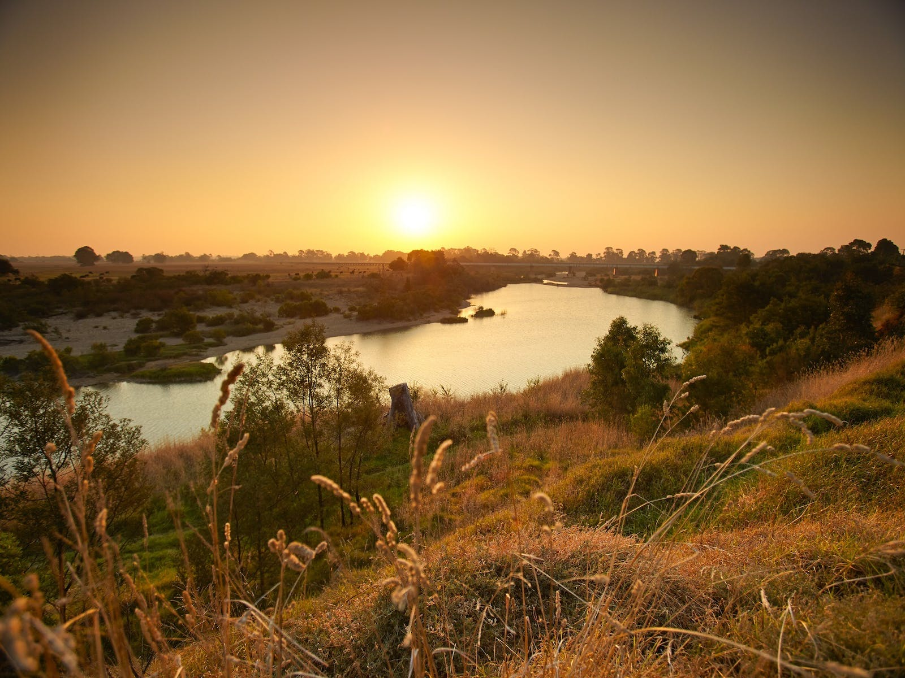

Dialogue agenda

Saturday 22nd November
9:30 Meet at Knob Reserve, at the oval shelter (morning tea)
10.00 Dialogue commence
Acknowledgement of country: Chris McEvoy
Welcome to country and smoking ceremony:
- GLaWAC: Gavin O’Shanassy
10:30 Co-Chairs introduction: Chris McEvoy
- Introduce Steve and Jess
Gippsland Forest Dialogue Background: Chris McEvoy
How today will work: Peter West
- Intent, Agenda, Housekeeping
  - Identify fracture lines – what we need to talk about in more detail
11:00 Participant introductions – Steve Pascoe
11:45 Field trip report backs
- Bairnsdale – Peter
- Noojee - Wally
12:00 Lunch
12:45 What do we know about fires – John Schauble
- Reflection on evolution of thinking on fires
- Summary of recent fire Inquiries (trends)
- Discussion – what have they missed
1:15 Dialogue – Socratic circle – Steve and Jess
Reflection on the 4 propositions - Steve
A vision: the future we want to see
“In 20 years, how will we be living with fire in forests”
- A double ‘yarning circle’
- Inner circle discusses, outer circle listens and notes
- Circles swap over and continue discussion
- Join up reflect with facilitators - Jess
Discussion led by facilitators
2:15 Short break – walk to lookout, with 2 discussion points
- Fire and orchids – Mitch
- Cultural burns - GLAWAC
Tea Coffee
3:00 How might we get to our vision – Steve and Jess
- What is stopping us
- Fracture lines
3:30 Where to from here – Peter
- Dialogue report
- Assistance to flesh out the vision
- Follow up dialogues on key topics and ‘fracture line’ from this event
3:45 “The Wrap” – Steve and Jess
- “Aha moment” activity
- Final thoughts
- Thanks, and final word - Chris

The dialogue process
The forest dialogue is an engagement approach developed at Yale University and practised in a number of countries around the world. It involves a process of engage, explore and change. Gippsland is the first Forest Dialogue group in Australia, formed 3 years ago and this is the 6th dialogue that has been conducted in that time.

What you can expect
The purpose of the dialogue and the group is to build trust and connection across stakeholders and community members interested in the future of our forests. Our intent is to provide a safe and respectful space where people can come and share their thoughts and importantly listen to views of others.
The group is not a decision maker or an advocate for any specific view or position. Whilst we look for opportunities for collaborative change, we do not force this.
Part of that safe place is that whilst we report on the conversation, but we do so in a way representing the various views but not specifically identifying individuals or their particular comments.
There is no guarantee of any specific outcome from a dialogue other than the building of relationships and learning you may take away for yourself or your work or interests.

What we expect of you
We expect you to approach the dialogue consistent with this in mind.
To share your knowledge and perspectives
To listen to others and show them respect and encourage their voice
To be open and curious and willing to empathise with others
To respect the privacy of participants and the confidentiality of what is shared

The dialogue model
The model as developed at Yale, and practiced in the Forest Dialogue community around the world has 3 phases
Engage – bring people together and build trust amongst those interested in the future of our forests
Explore – share information and perspectives on the subject and gain understanding of points of agreement or common ground and “fracture lines”
Facilitation of collaborative action – report on findings, identify actions or advocacy where consensus or collaborative approach
Gippsland forest dialogue sees its key aim and building relationships and trust, and from this action will flow. This has been demonstrated in the relationships formed at dialogues and the reflections of attendees.
Exploration of themes identifying common ground and points of contention are captured in dialogue reports.
Specific actions usually flow as a consequence from the dialogues but some examples include submissions to enquiries, collaboration on funding bids between partners, advocacy for vulnerable our unheard voices

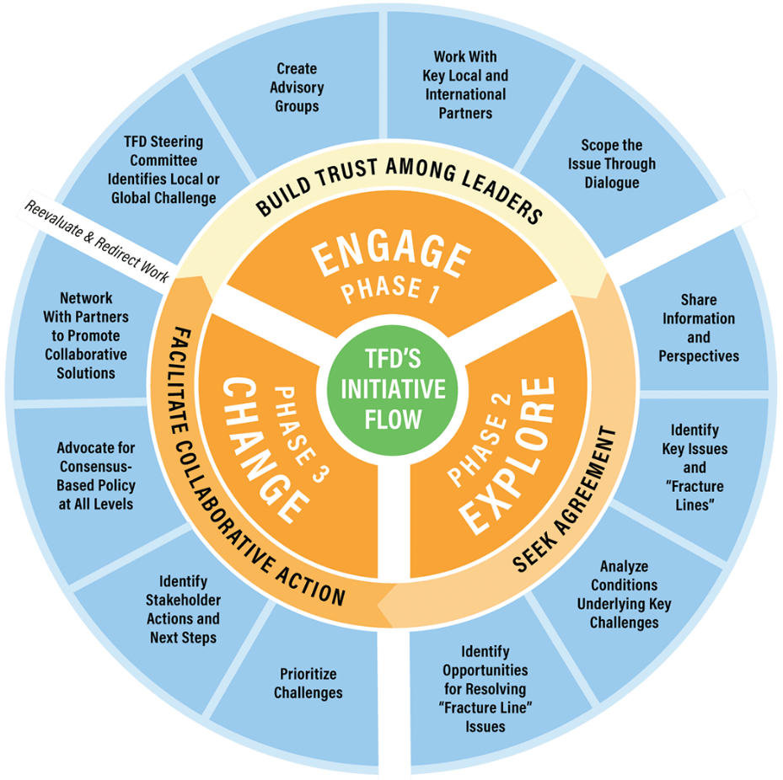

Scoping statement and questions to lead the discussion
For each of our dialogues, we develop a scoping document to provide context and identify open questions to lead the discussion. The scoping document will provide a lot of detail; the following is the questions we want to use to lead the conversation.
Fire is a very large topic, for this dialogue we want to open up the conversation, and identify key areas or themes which may require further explorations at more focused follow up sessions.
To structure this we have identified 4 key propositions to explore and also summarized the findings of recent Inquiries.
For each proposition, we have some statements and open questions, the intent of these is to stimulate conversation and provide focus for the discussion. That discussion may include disagreement or challenge of these propositions and statements. During the course of the dialogue other questions may be raised.
The propositions are
- Fire is natural
- Fire is dangerous
- Fire is useful
- Fire is changing
These are discussed in Background sections of the scoping document and we hope to use these propositions to lead to a vision. How do we want to be living with fire in our forests in 20 years time?

In addition to these propositions and related questions, we will investigate the core findings across Victorian Bushfire Inquiries namely:
- 2002 COAG National Bushfire Inquiry
- 2003 Esplin inquiry (Victoria)
- 2009 Black Saturday Royal Commission
- 2010/14 Implementation and reform reviews (monitor or Royal commission recommendations)
- 2015 IGEM Review of fuel management
- 2019/20 IGEM Inquiry Victoria
- 2020 Royal Commission into National Natural Disaster Arrangements – Bushfire Royal commission)

Background

Recent fire history
Signficant Fire Events for Gippsland | Percentage of area burnt in Victoria | Total Hectares burnt Gippsland of Vic total
2019/2020: Black Summer: 28 fires | 76% | 1,363,100- 1,786,250
2018-2019 : 79 fires | 93% | 198,492 Gipps/213,049
2017-2018 :48 fires | 52% | 29,636 Gipps/57,365
2013-2014: 71 fires | 49% | 197,418 Gipps/404,937
2012-2013: 32 fires | 46% | 90,965 Gipps/ 199,812
2010-2011: 11 fires | 89% | 11,986 Gipps/ 13,524
2009-2009: Black Saturday 34 fires | 26% | 117,195 Gipps/446,245
2006-2007: 16 fires | 91% | 1,099,410 Gipps/1,207,892
2002-2003: 23 Fires | 87% | 1,374,267 Gipps/ 1,577,004
1997-1998: 48 fires | 73% | 40,446 Gipps/ Vic 55,281
1982-1983: 27 fires | 62% | 360,227 Gipps /Vic 580,260
1980-1981 : 30 fires | 34% | 153,630 Gipps/Vic 457,680
1977-1978 :9 fires  1964-1965:12 fires | 36%  77% of Victoria fires | 25,980 Gipps/Vic 72,565  482,333 Gipps/Vic 596,444
1938-1939: | 76% | 2,588,638 Gipps/Vic 3,417,937

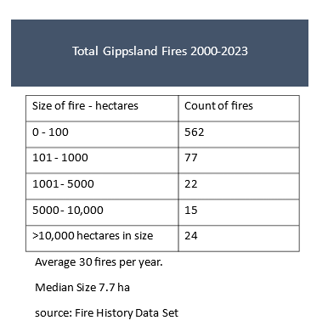

Victoria’s Bushfire Management Strategy for public land

Overview
Victoria’s Bushfire Management Strategy (VBMS) sets a 10-year vision for how Victorians will work together to reduce bushfire risk, strengthen resilience, and protect communities, ecosystems, cultural heritage and critical infrastructure in a rapidly changing climate. The Strategy is built on shared responsibility, partnership with Traditional Owners, and evidence-based decision-making.
The Strategy acknowledges that Victoria is one of the most bushfire-prone regions in the world, and that climate change is driving more frequent, severe and complex fire behaviour. As the document states, “Climate change is increasing the severity and frequency of bushfires” (Introduction). It outlines seven domains that collectively shape a safer, more resilient future.

Why the Strategy Is Needed

Escalating bushfire risk
Victoria has experienced multiple catastrophic fire seasons, including Black Friday (1939), Ash Wednesday (1983), Black Saturday (2009), and Black Summer (2019–20). These events caused profound loss of life, homes, biodiversity and cultural heritage. The Strategy notes that “more than 60% of all bushfire deaths in Australia have occurred in Victoria” (Looking Back).
Climate change is already shortening planned-burn windows, increasing lightning-ignited fires, and driving more extreme fire weather. Fire seasons now start earlier, last longer, and burn larger areas.

Changing communities
Population growth in peri-urban and regional centres increases exposure to bushfire risk. New residents often lack local hazard knowledge, while vulnerable groups may face additional challenges during emergencies.

A new era of partnership with Traditional Owners
The Strategy recognises cultural fire as a vital land management practice and commits to removing barriers so Traditional Owners can lead cultural burning and broader fire management decision-making.

The Strategy’s Seven Domains

1. People and Community Safety
Communities are central to resilience. The Strategy emphasises:
- Empowering communities to understand and manage local bushfire risk
- Supporting at-risk cohorts through education and collaboration
- Using diverse mitigation strategies (planning controls, ignition prevention, compliance)
- Delivering fuel management suited to a changing climate
- Improving early detection and rapid suppression
- Strengthening community-led recovery
The Strategy highlights that “communities that understand and are prepared for the risk of bushfire are more resilient” (People & Community Safety).

2. Critical Infrastructure and Economic Resilience
Bushfires disrupt essential services, supply chains and local economies. The Strategy commits to:
- Planning for economic impacts across all phases of bushfire management
- Embedding industry expertise in planning and response
- Reducing ignition risks from infrastructure (e.g., powerlines)
- Investing in resilient infrastructure and climate-ready design
Case studies such as the Powerline Bushfire Safety Program demonstrate large-scale risk reduction.

3. Aboriginal Self-Determination in Cultural Fire and Bushfire Management
The Strategy aligns with the Victorian Traditional Owner Cultural Fire Strategy and commits to:
- Enabling Traditional Owners to lead cultural burns across all land tenures
- Strengthening governance, cultural knowledge and practice
- Supporting collaborative land management
- Reforming institutional frameworks to embed cultural fire
- Expanding Traditional Owner roles in broader bushfire management
The document states: “Only Traditional Owners have the authority to lead cultural fire management on Country” (Cultural Fire).

4. Ecosystem Resilience and Nature Conservation
Healthy ecosystems underpin successful fire management. The Strategy focuses on:
- Improving data, tools and ecological fire knowledge
- Integrating climate science into planning
- Monitoring ecosystem resilience and setting ecological targets
- Strengthening environmental value assessments
- Building community understanding of fire regimes
Examples include reseeding Alpine Ash forests after repeated fires.

5. Informed Decision-Making and Evidence-Based Tools
Victoria will invest in:
- High-quality shared data and research
- Advanced fire behaviour modelling (Phoenix, SPARK)
- Transparent, evidence-based decision-making
- Integration of Traditional Owner and community insights
The Strategy emphasises adaptive management — “learning by doing” — to continually refine fuel management and planning.

6. Working Together, Accountability and Shared Responsibility
Shared responsibility means:
- Strong collaboration between agencies, communities, industry and Traditional Owners
- Integrated planning across public and private land
- Transparent reporting and community access to risk information
- Clear roles for individuals, communities and agencies
The Strategy reinforces that “no single actor can be responsible for emergency mitigation, preparedness, response or recovery” (Shared Responsibility).

7. Enhanced Capability and Capacity
To manage longer, more intense fire seasons, Victoria will:
- Standardise systems and improve interoperability
- Invest in training, mentoring and leadership development
- Strengthen physical and mental health support for personnel
- Increase diversity and inclusion across the sector
- Build year-round, all-hazards capability
- Secure modern equipment, aviation assets, and resilient infrastructure

Implementation and Monitoring
Delivery will be supported by:
- A rolling 3-year Implementation Plan
- A Monitoring, Evaluation and Reporting Framework
- Regular Strategy reviews (every 5 years)
- Clear outcomes, indicators and targets
This ensures accountability, transparency and continuous improvement.

Overall Significance
Victoria’s Bushfire Management Strategy is a whole-of-state roadmap for living with fire in a changing climate. It integrates science, community knowledge, cultural fire practice, and cross-sector collaboration. It recognises that resilience is built through partnership — between government, communities, industry, and Traditional Owners — and that protecting life remains the highest priority.
The Strategy’s vision is clear: Victorians work together to manage bushfire risk for safer communities and healthy ecosystems in a changing climate.

Findings of recent enquiries
The following table gives a comparison of how some major themes were presented in these inquiries
Theme | 2003 Esplin | 2009 Royal Commission | 2019 IGEM | 2020 National Royal Commission
Climate change | Not a major focus | Emerging concern | Central driver of fire behaviour | Long term risk – National priority
Fuel Management | High fuel loads major issue | Strong push for planned burning | Fuel management important but not sufficient | Support a risk based ecological approach
Forest Management | Need better coordination | Limited focus | Forest health declining need active management | Supports integrated cross tenure management
Emergency warnings | Improve communication | Major overhaul needed | Systems improved but still vulnerable | Need national consistency
Evacuation | Limited | Clear policies needed | Large scale evac now common, routes vulnerable | National framework needed
Community preparedness | Community education needed | Shared responsibility model | Local knowledge essential, volunteers stretched | Strengthen resilience planning
Traditional Owner leadership | Minimal | Minimal | Strong emphasis on cultural burning and leadership | National support for indigenous fire knowledge
Biodiversity and ecosystems | Limited | Some concern | Severe ecological impacts, species at risk | National biodiversity risk highlighted

What the inquiries have said?
Over the past 20 years, Victoria has faced some of the most destructive bushfires in Australia. Each major inquiry — from the 2003 Alpine fires to Black Saturday and the 2019–20 Black Summer — has taught us something important about how we live with fire.
Across all these reviews, a clear message emerges:
Bushfire risk is rising, and we need long-term, collaborative, community-centred approaches to keep people and landscapes safe.

1. Our climate is changing
Fire seasons are getting longer, hotter, and drier. This means:
- More days of extreme fire danger
- Larger, faster-moving fires
- Greater pressure on emergency services and communities

2. Fuel management helps — but it’s not enough
Prescribed burning and fuel reduction are important tools, but no inquiry has found that they can solve the problem alone. We need:
- A mix of strategies
- Ecological and cultural knowledge
- Long-term forest health planning

3. Forests need active, long-term care
Recent inquiries show that many forests are stressed, recovering slowly, or burning too often. Healthy forests are more resilient — and that requires:
- Better coordination across land tenures
- Traditional Owner leadership
- Investment in long-term management

4. Communities are central to bushfire resilience
Every inquiry highlights the same truth: Local people know their landscapes best. Stronger community resilience comes from:
- Clear, timely warnings
- Local planning and preparedness
- Support for volunteers and community groups

5. Traditional Owner knowledge is essential
Cultural burning and Indigenous land management are increasingly recognised as vital for:
- Reducing risk
- Supporting biodiversity
- Strengthening cultural connections to Country

6. We need to plan for large-scale evacuations
The 2019–20 fires showed that whole regions may need to evacuate at once. This means:
- Better evacuation routes
- Clearer communication
- Planning for tourists and seasonal populations
Across two decades of inquiries, the direction is clear:
We need to shift from reacting to fires to preparing landscapes and communities for a changing climate. This requires collaboration — government, Traditional Owners, communities, industry, and volunteers working together.
Key literature – reference review
Our fire dialogue webpage provides a link to research papers themed around forest fire.
There is a significant history of research undertaken by AFAC, CSIRO, Natural Hazard and Australian universities.
Key voices and their views
There are a number of people and groups with strong views on fire management in forests. In our reference section for this dialogue on our webpage, we have a number of papers presenting some of these views, including those of David Lindemeyer, Phillip Zylstra, Peter McHugh, recent fire enquires and fire agencies.

Field trip reports
Below are notes from the two field trips undertaken a fortnight prior to the dialogue
Noojee
Stop 1 - views of Toorongo, Baw Baw plateaus from the south (Cheryl Drayton, Owen Salkin)
- Discussion on indigenous perspectives - we are invited (with accountability) to "look at, preserve and protect Country." Local TO boundaries are in dispute.
- Local geology influences distribution of forest types. We need to be mindful that forest succession cycles could be viewed in geological time scales. E.g. Over a 10,000-year period, this equates to 20 x 500-year cycles of transition between eucalypt dominated (drier) and beech dominated (wetter) forest.
- Fire history has influenced the distribution of patches dominated by eucalypt Vs acacia Vs Nothofagus. Some discussion around impact of fire frequency on recovery of species that regenerate via seed vs lignotuber. We are due for another fire!
- A wide range of local interests present. Several people with forest management background present - plantation and native, local and elsewhere. Local land owners, community members and leaders of community enterprise, climate change activists, recreation enthusiasts, families, people who've experienced the pointy end of wild fire, those who declare a "love of trees and forests!" Researchers, state & local government.
- Some notable statements during attendee introduction's:
From a teenager who has just moved to the region: "I'm curious - what's this place actually like?"

From a local young woman: "I think trees are cool!"

From a land manager & farmer who experienced the Black Saturday fires: "I have strong opinions!"

From Indigenous rep: "The Kurnai are warriors."

Stop 2 - Owen's place (management of fire risk on private bush block) (Owen Salkin)
- This is hard country for farming. Government encouraged clearing, but then it was too steep to farm easily. Most of the bush is regrowth forest. Regeneration of cleared land is harder now due to deer browsing pressure on young seedlings.
- Owen loves living in the bush, but understands the fire risk. He knows he has a responsibility to manage his site to reduce the risk for himself and his neighbours. He considers himself a custodian of the land. He is focused on protecting the house.
- Owen practices active prescribed burning on a yearly basis. He likens this to "gardening" the bush. He understands where and when different parts of his block should be burned (north, east and west aspects to deal with). He considers both risk to the house and species ecology. Eg he burns ~ 0.25 - 2ha per year, each patch may get burned every 5-10 years. He has the experience and access to friends/ infrastructure to know how to do this and when (how can his less experienced neighbours access support to build capacity for this type of activity)?
- Owen feels safer from the risk of wildfire knowing that he has reduced the risk via prescribed burning. He plans to "stay and fight" in the event of another wildfire.
- He discussed BAL ratings and the risk zones for houses in the bush - how it is possible to choose building materials that reduce fire risk.

- Noojee township declared as not able to be protected from a significant wildfire event - upsetting/ surprising to some. Owen can speak to this with the integrity and confidence of an experienced fire manager and a local with skin in the game who is committed to doing what is possible to protect the town.
"I believe in the science (of forest fire management/ behaviour). I like learning from observation."

"Burning is not for everyone, or every location, or every time."

"I like setting fire to things! There is a satisfaction in doing it well."

Stop 3 - boundary between management zones with different harvest & burn histories (1989 regrowth next to 2011 regrowth) (UoM - Jane Cawson, Tom Fairman, Patrick Baker)
- The region is a mosaic of forest types and structures and age classes resulting from influence of geology & topography & harvesting, wildfire & prescribed burn histories.
- The area that has been disturbed more recently (2011 regrowth) looks like it has a more dynamic & vertically/ horizontally connected forest structure, as the dominant eucalypt storey is shorter, the understorey and mid storey are younger with full crowns. This connectivity may make it more flammable. The area that has been undisturbed for longer has greater separation between eucalypt overstorey and shrubby understorey. Some of the acacias have senesced or been outcompeted. The overstorey is quite dense and shading out the understory. Mostly silver top, messmate, Mt Grey. A lot of rough-barked species that will carry fire to the canopy. Both patches likely to progress in the same direction towards similar forest structure/ composition.
- (Jane & Tom) - discussion on what influences flammability, and how this is measured. How does this differ between the forest patches observed at the site.
- Question from group on relative flammability of mature foliage Vs young foliage (oil content) - research on this is uncertain.
- Discussion on how fuel assessments feed into models predicting fire behaviour and risk.
- (Patrick) - discussion on how we can use silviculture (ecological thinning) to manage forest regrowth so that more trees get bigger faster, thus increasing their resilience to fire, and reducing fire risk in the landscape. Different species grow at different rates (e.g. to fast track a shift from 2500 sph to 250 sph over a shorter period than 400 years)! Eg - thinning from below.
- Now that public native forest is no longer managed for economic outputs, it is hard to find budgets and resources to encourage thinning practices. How receptive will the community be to finding economic uses for thinned materials to pay for the need to thin for ecological protection.
Stop 4 - prescribed burn site next to farm (Patrick's farm) (DEECA - Quinton Pacan)
- Legislation and policy provide a framework for how each patch of public native forest is zoned and prioritised for fire risk and management strategies. These take into account risk to houses, infrastructure, economic assets (farms, fences, industrial estates, plantations), ecological assets etc.
- Recent bushfire management strategies have increased attention to interaction between public and private fire risk management. CFA & DEECA have developed joint fuel management plans where public and private estates intersect.
- Tolerable fire intervals are different for different zones (eg asset protection zones 5-10yr burn frequency, bushfire moderation zones 10-20yrs, landscape management zones 15-20yrs +). Management prescriptions are allocated to different localities depending on objectives, risk levels, forest types etc.
- As climate conditions get more inconsistent and extreme, and the public appetite for fire management activities gets more fraught, the prescriptions increasingly require "goldilocks conditions" to achieve a good prescribed burn. Not too windy or wet or dry. Windows of opportunity for this are getting smaller.
- There are treatments other than burning that are available for managing fuel - mulching, chopping etc. Research into alternative strategies is ongoing. How to find strategies that are financially viable?
- The neighbouring farmer said he considers this prescribed burn as significant insurance for his farm and Noojee.
- Some observed that young regeneration under 5 years of age have been shown to be less likely to burn - and can provide a "fire break" effect in a mosaic landscape.
- Discussion around whether collecting fuels and processing through a pyrolysis plant for soil ameliorants that can be used/ sold in the local economy etc is a viable alternative to burning - likely to require a self-driven market.
- Example of Kinglake community in previous wildfire being able to respond more effectively through having engaged proactively before the fire season in fire preparedness, good local emergency response network, "phone tree" etc.
- There is a need to educate newbies to town that in an isolated community like Noojee, individual properties must be self-sufficient for power and water to bother "staying to fight" a fire - can't rely on mains supply etc.
- DEECA has less resources than ever before - community needs to be more involved in fire preparedness and more proactive in driving engagement with DEECA in a targeted way to help get what they need.
From farmer Patrick adjacent to public native forest: "this fuel reduction burn is worth $1M insurance for our farm and for the (nearby) township of Noojee."

Farmer Patrick: "if we are going to protect small communities, we need to do fuel reduction burning."

Bairnsdale
Stop 1: Cultural burning
Cultural burning, at its core is about caring for the country. Given the significant changes to the landscape with European intervention and the past 25 years of fire there is also a belief it is about healing the country and people.
Typically, cultural burning is about “Small scale, low intensity frequent burns”. At this site, near the GLAWAC office (Gunaikurnai Land and Waters Aboriginal Corporation) we inspected forest where GLAWAC has practiced cultural burning.
Cultural burning is low intensity burning: a manifestation of connection to the country and community. Traditional Owners have an obligation to care for the land. In undertaking cultural burning, it is important to listen to the land, and not just burn by numbers.
An important aspect is getting people on land and connecting with one another, rather than how many hectares are burnt. Unfortunately, GLAWAC were unable to be in attendance during the day, so there was a level of discomfort in speaking on their behalf but it was important to share our understandings. It is hoped a representative will be able to make it to the Knob Reserve dialogue.
In talking to Aboriginal groups as part of an inquiry post the 2019 fires it was evident, different Aboriginal groups in Victoria had different views on the fires and their impacts. A key theme was that people can’t be healthy if the land and forest aren’t healthy.
It was noted in the discussion that “for a long time, we didn’t talk to Aboriginal people about fire and healthy forests. Thankfully, now we do more so”.
What do Aboriginal people view as a healthy forest? A view put forward was that healthy forest includes large and small plants, as well as those that are missing—not only endangered species, but also a decrease in deadwood, and an increase in medicinal plants. Forests are open, you can see through them.
Traditional owners have been shut out of forests for so long and have lost some of their cultural burning knowledge. They need space to relearn and then implement at scale. We need to work in partnership with them to do this. To boost forest resilience, we need a lot of learning from Aboriginal peoples.

Another aspect of the discussion was, “what is cultural burning”.
The question was asked, are we misinterpreting cultural burning, do we value forests and cultural burning through a Western lens rather than an Aboriginal lens?
A view was put that Cultural burning is being used for an agricultural purpose rather than an ecological one. It assists in hunting, medicine, food, and foraging. Boosting biodiversity can be impacted as 95% of biodiversity is in leaf litter.
There are many nuances in cultural burning: Early settlers saw forests that were vastly different from today’s — densely cluttered landscapes.
A trial currently being undertaken in the Strathbogies was discussed, it is a “Two Worlds Forest Management” concept aimed at bringing traditional knowledge and science together. GLAWAC strongly support using both knowledge bases and collaborating with land managers.
We then discussed examples of GLAWAC working with DEECA. This involved joint training in firefighting, land management and forest management. GLAWAC are now partners in Forest Fire Management Victoria and can respond to bushfires, not just be consulted. A formal agreement has been signed that gives a legal framework to make it easier to undertake cultural burning on public land. This is paired with arrangements that make GLAWAC a partner in bushfire suppression.
Information exchange and knowledge sharing are part of the agreements. It was also stated that Indigenous people, when they undertake cultural burning, don’t want to have “green overalls” looking over their shoulders.
It was noted that there’s increasing literature on cultural burning and the NIDA conference was referenced.
A reflection was that cultural burning is about community, not ecological values or fuel management; it’s about “Sharing a fire, with friends and forging connection.
One concern raised was that more and more burning of scarce resources is wasteful behaviour and we should be more measured in how much burning we allow, whether that is bushfire, fuel reduction, ecological or cultural. Shouldn’t we be using our resources better? “We are a country, a part of the landscape and ecosystem. Little kids miss out on future forests if we burn them now.
Humans living approximately 23,000 years ago thrived in these forests in East Gippsland. Some things respond to fire and come back over time. “Fragmented forests are what we have now. There was a bigger estate, and it could handle fires better.
“Should we be managing our remaining forests by using fire We now put out fires in summer that used to happen naturally. Refer to Susan Sinard’s book on underground fungal networks in forests. Listen to the landscape and respond accordingly. “Different seasons require different management. Detritus and dead sticks and ecologically important but detritus build up leaves’ community members feeling uncomfortable as they are a fire risk, but they are an asset to biodiversity.

Stop 2: A planned burn
We inspected a planned burn with a DEECA representative explaining the process and strategy behind where they burn, how they plan and implement it.
We visited a burn on Wards Road.” This burn was conducted two years ago, in the autumn of 2023.
The Code of Practice guides overall management and zoning systems, including landscape management zones and exclusion zones. However, we have three-year operational plans, which show where burns are actually targeted. This burn occurred in a “Bush Fire Moderation Zone” which is for large hinterland areas to moderate large fires.
“When planning a burn, we assess a number of values prior to doing the burn: Effects on road access, safety, and biodiversity, cultural values, operational feasibility, and other factors. “We must wait for the appropriate weather.” We do not just burn at any time.
There are resource pressures. “Planning is done at the state level; The actual burn area is unspecified. It is usually much smaller than the planned burn area shown on a map. For example, there may be exclusions to habitat or areas simply too wet to carry fire in the fire perimeter. “Nuance like this isn’t communicated well to the public.
Different techniques are used for ignition, e.g., spot ignition, aerial ignition (in more inaccessible areas) and strip burn. “Crews will patrol for 4 to 5 days after ignition to ensure it doesn’t escape. At this burn, there are a number of She oaks which are feed trees for Glossy Black Cockatoos. So, we had an ecologist monitoring the feeding trees both before and after the burn. DEECA worked in collaboration with Birdlife Australia on this monitoring and consider submission of Citizen Scientist data. Monitoring, as well as communication management, is challenging. DEECA try to put more detail in community information. However, if the community is dispersed, it can be hard to get nuanced information out. “When forest users may come from an outside area, such as Melbourne it can be difficult to get the message across, cultural burn communication is undertaken through traditional owners. “However, engagement and communication sometimes present resource challenges.
Forest Fire Management Victoria is led by policies that operate at a high-level state level; Sometimes, however, these policies may lack local nuance in their communication. “A few people raised concerns. “From communities about Plan Burn impacts, we discuss strategies for getting information out to stakeholders, partnering with community groups, land care, and using social media networks, etc.
Resource constraints can limit these efforts to engage with the community.
“Reflection: “Is intervention in the forest good or bad? “Robust words.” What is the scale around this question? What is the scope, EG? Is something like deer control a good intervention? Is fire response good or bad? Other roads we drove today, good or bad, if we want to respond to fire. We visited the forest, or understand monitoring. “We need access. Does the scope of intervention end at the current forest boundary? And just driving on an internal combustion engine is an intervention which affects the forest.

Stop 3 Lunch and dialogue discussion
Over lunch a handout on the four propositions was provided and discussed. It was explained these may be used to shape and stimulate the discussion at the dialogue.
Discussion included: Were the propositions true in the past? Was fire always dangerous? Have our landscapes become so modified that fire is no longer a threat? Fire behaves in a way that it is no longer natural. “We discuss the importance of getting out to see the effects.

Stop 4 2019 fire reflection
“The fires in 2019 and 2020, which occurred due to multiple lightning strikes, over 30 in the one afternoon. Priority was given to asset protection.
“Victorian resources were already deployed in New South Wales and Queensland from early on in that fire season Given the circumstances, there was a national resource issue.
“Every fire that occurred from those lightning strikes was responded to: for each there was someone on it in the first 24 hours. But that wasn’t enough, whilst most were put out, 4 were not and these grew into the large mega fire.
Prepare for fire by conducting landscape burns in all zones. “Strategic planning and fuel reduction facilitates suppression when bush fires occur.
A question was raised that” There was a 14-to-15-year program of burning prior, yet the fires still occurred, was planned burning useful”. We discussed whether the fuel reduction burns prior to the wildfires of 2019-20 prevented them, and what their effectiveness was in megafires, given that planned burns are most effective one to two years after completion and their impact deminishes past that.
It was discussed that planned burning is only part of a fire program, fuel is one driver of fires we can influence, it is hard sometimes to quantify their impact.
“We discuss where fuel reduction burns are still helpful in suppressing fire.

Stop 5 Sarsfield
Visit the community hall and Sarsfield community association. Sarsfield was one of the first communities in East Gippsland to be significantly impacted by the 2019 fires. Two hundred properties were impacted, and eighty houses were burned down. “Half of Sarsfield’s land area was burned, particularly more in the densely populated part of town.
“The community hall was not impacted and became an important gathering place. Recovery funds were available for the community. “This process brought the community together to determine what was needed. Sarsfield Community Association was born out of this process. The Council took over. “And $3 million was allocated for the community hall. “However, due to delays in application, this sum may not have been enough. The cause of delay is the bureaucratic process,
Since the fire many houses have been built. There has been a fair turnover in people since the 2019 fire. This means there’s a need to build capacity and community to prepare for the next fire season. The Sarsfield Community Association is involved in coordinating the Bush Reserve, located near Sarsfield, which is considered a fire hazard by some community members. “The Sarsfield Community Association’s remit in reserve management is unclear.
The community’s attitude and feeling toward fire risk have become more blase over the last five years, as the weather has been wetter and fire seasons quieter. “Also, because houses that have been built subsequently tend to be more resilient, which may suggest that people aren’t as prepared; people perhaps feel that they won’t experience another mega fire in their lifetime.
“Fire also creates positive connection in the community. In Sarsfield. “The fires created the impetus for community connection. Working with neighbours before and after the fire in the recovery phase, and this still persists to today.” The community received funding to employ someone part time to do admin and manage membership for their association which was important.
Every community that experienced Black Summer fires experienced it differently. “The fire created opportunities to connect with individuals doing similar work in other places across the state, which helped the community, especially the mentor relationship with people from Strathewyn. One observation is it is difficult to pick yourself up from scratch after an event and set up community structures so good to have this in place before a fire.
You should not attempt to set it up after a disaster, but have mechanisms and structures in place beforehand. Some ongoing challenges with the hall, include determining responsibility, insurance. “Minor damage may not meet the excess as stipulated by the Council. The statement is that the committee would have to cover that cost. It could also be relevant for daytime groups, although there are fairly high annual costs associated with starting a community association, including administration, electricity, and other similar expenses.
Emergency planning, the hall is not a safer place for refuge, but rather a secondary space.

Some themes that have emerged from the field trip:
There is power in talking about the forest. “In the forest, there is also power in talking about planned burning while you’re looking and walking in planned burns,
Forests are a huge mental health resource. They offer the quiet, reflective space, and should be valued as such; as an important contributor to mental health.
Cultural burning is not ecological or fuel management. It is more natural resource management, and people connection, and cultural knowledge transfer.
Planned burning is important but has its limitations and impacts.
Whist planned burning, ecological burning, cultural burning and natural fire all have their place, there should be some limit to the amount of fire in the landscape

Fire is natural
Our first proposition to explore, contest, discuss, question is that fire is a natural process, and we must learn to live with it.
- Nature starts fire (lightning starts 20% of all modern bushfires)
- Nature promotes fire (flammable vegetation, accumulated fuel)
- Our forests, their species distribution and structure are shaped by fire
- Our plants and animals are adapted to fire (regeneration, food, shelter)
- Different regimes (intensity and frequency) favor or impact different plants and animals
Questions
- What is your reaction to this proposition
- How much fire is good for our forests
- What is a natural fire regime
Victoria’s landscapes—its forests, grasslands, heathlands, and alpine environments—have been shaped by fire for millennia. Wet winters promote vigorous plant growth, while hot, dry summers create ideal conditions for bushfire. Fire is not an anomaly in this environment; it is a natural ecological process that has influenced the evolution of plants, animals, and entire ecosystems.

Fire in the Victorian Landscape

A Climate That Fosters Fire
Victoria’s climate—cool, wet winters followed by hot, dry summers—creates abundant vegetation growth that later dries and becomes fuel. This seasonal pattern makes fire a predictable part of the environment.

Lightning as a Natural Ignition Source
Lightning is the primary natural cause of bushfires in Victoria. Between 1979 and 1998, lightning ignited 3,314 fires—an average of 166 fires per year. These strikes often occur in remote or rugged terrain, allowing fires to grow before detection.
Lightning ignitions are especially common during summer thunderstorms, when dry vegetation and high temperatures create ideal conditions for fire spread.

Fire Behaviour in Victoria

Why Victorian Fires Are Often Intense
Victoria’s diverse landscapes—grasslands, foothill forests, mountain ranges, and coastal heathlands—contain vegetation types that burn readily and intensely. Dry grasses ignite easily, while forests dominated by ribbon-bark and stringybark eucalypts produce large embers that can travel ahead of the fire front, accelerating spread.

Fuel Continuity and Terrain
Continuous tracts of forest in eastern Victoria, combined with steep terrain and dense understorey, can produce fast-moving, high-intensity fires during hot, dry periods. Western Victoria’s more arid conditions mean grassfires are frequent and can spread rapidly across open plains.

Vegetation Adaptations to Fire
Fire has shaped the evolution of Victorian flora. Many species not only survive fire—they depend on it.

Resprouters
Some plants, such as many eucalypts, can resprout from protected buds beneath their bark or from lignotubers underground. This allows rapid recovery after fire.

Seeders
Other species rely on fire to trigger regeneration:
- Eucalypts and hakeas store seeds in woody fruits that open after fire.
- Wattles have thick seed coats that protect seeds during fire and allow germination afterward.
- Some species maintain soil seedbanks that survive fire underground.

Fire-Dependent Flowering and Growth
Certain plants flower more prolifically after fire, taking advantage of increased light, nutrients, and reduced competition. Grass trees (Xanthorrhoea australis) are a well-known example, often producing dramatic post-fire flowering.

Maintaining Ecosystem Structure
Fire helps maintain:
- Open forest floors
- Diverse age classes of vegetation
- Habitat mosaics that support a wide range of species
Without fire, many ecosystems become overgrown, lose biodiversity, and accumulate hazardous fuel loads.

Animal Adaptations to Fire
Victorian fauna have evolved behavioural and physical traits that help them survive fire.

Mobility and Refuge Seeking
Animals such as kangaroos, wallabies, and wombats respond to fire by:
- Fleeing ahead of the fire front
- Seeking refuge in burrows, rocky areas, or waterways
- Returning quickly to burnt areas to feed on new growth
These behaviours are well documented in Victorian ecosystems.

Post-Fire Survival
Many species can survive even severe fires. For example, swamp wallabies have been observed surviving major fires in the Big River catchment, demonstrating resilience and adaptability.

Ecological Benefits for Wildlife
Post-fire environments often provide:
- Fresh, nutrient-rich vegetation
- Increased habitat diversity
- Improved access to food resources
These conditions support population recovery and long-term ecological health.

Fire as an Ecological Process

Fire Regimes
Ecological outcomes depend on fire regimes—patterns of frequency, intensity, season, and scale. Different ecosystems require different fire regimes to remain healthy.

Fire and Biodiversity
Fire promotes biodiversity by:
- Creating habitat mosaics
- Supporting fire-dependent species
- Preventing dominance by a single vegetation type

Long-Term Evolutionary Influence
Over thousands of years, fire has shaped:
- Species traits
- Vegetation distribution
- Landscape patterns
Victoria’s ecosystems have evolved with fire—and because of fire.

Conclusion
Fire is a natural and essential part of the Victorian environment. Lightning ignitions, flammable vegetation, and species adapted to fire all contribute to a landscape where fire plays a central ecological role. Plants and animals have evolved to survive—and often thrive—after fire events. Understanding fire as a natural process is crucial for sustainable land management, ecological conservation, and community resilience.
Over the last century, with the advent of fire authorities, it has been policy to aggressively attack and put out all fires, but should we allow some natural fire to occur, and if so, where and when is that appropriate and within an acceptable community risk tolerance. Could we foresee a time in 100-200 years where forest structure could revert to pre colonisation through more targeted suppression on high-risk fires in peak season and a more tolerance of low-risk low intensity natural fires.
Fire will continue to shape Victoria’s landscapes. The challenge is not to eliminate fire, but to work with it—guided by science, cultural knowledge, and ecological understanding.

Fire is dangerous
Our second proposition is that fire is dangerous and poses a threat to people, communities, their property and also to the natural environment.
- Fire can kill people (200+ in Victoria in the past 20 years)
- Fires can kill animals (domestic and native)
- Fires can change ecosystems
- Some species are vulnerable to fire
- Water quality and quantity can be affected by fire
- Health can be impacted by fire
- Fires destroy towns and impact social cohesion
- Fire destroys opportunities to see ‘untouched nature’
Questions
- What is your view on this proposition
- How can we protect ourselves and our forests from fire
- How can we prepare ourselves for fire and build resilience
- What is the right balance, what do we need to prioritize

Managing bushfire risk
Effective bushfire risk management requires a multi-pronged approach that includes:
- Reducing bushfire ignitions
- increasing the effectiveness of fire suppression
- reducing bushfire spread and severity
- reducing the physical effects of bushfires in inhabited areas
- reducing the social effects of bushfires on communities
- reducing the impacts from fire management actions.

Mechanisms used to reduce risk include:

Reducing ignitions and increasing effectiveness of suppression
Reducing bushfires and their impacts involves both identifying and, where possible, acting to prevent or reduce human caused ignitions (arson, escaped burn offs, untended campfires) as well as enabling the early identification and first-attack suppression of fires.

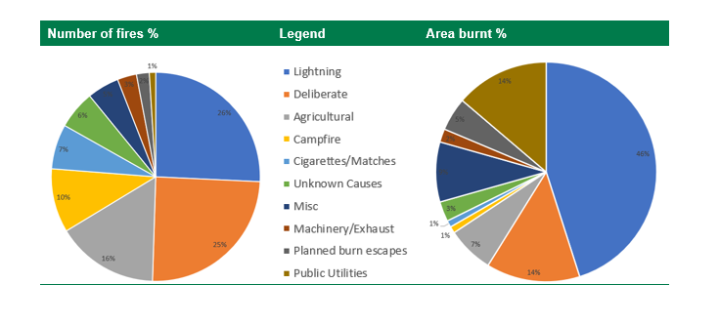

The table above shows the causes of fires and their impact in terms of percentage of area burnt
Programs that help minimise human caused ignitions include seasonal fire restrictions and total fire bans on high-risk days, along with targeted patrols of recreational sites to ensure campfires are properly managed. The effectiveness of suppression depends on a number of things including early identification of ignition points, having sufficient skilled staff available to respond quickly, ensuring they are able to reach them safely, and that they have the necessary equipment to support their suppression activities.

A key to first attack success is getting to fires quickly and this relies on a good road network. At present a road network of 16,000 kilometers is exists in Gippsland’s
National Parks and State forests. Investment is this network is prioritized for both standard and maintenance based upon its strategic importance to the quick and successful suppression of fires, especially in first attack.
Approximately 2300 kilometers is classified as highly strategic and maintained regularly to a standard able to transport heavy machinery and firefighting equipment. A secondary level of another 2000 is maintained to a safe standard for firefighter access and the remainder receives minimal maintenance but can be used for access when required.
As the numbers in the following table attest, a high percentage of fires are controlled quickly in first attack operations, but almost all the impact and damage is caused by a relatively small number of ignitions which are not controlled early.
Understanding which ignitions pose the biggest threat and being able to prioritize response is important, this is the basis of a risk-based approach to fire management.
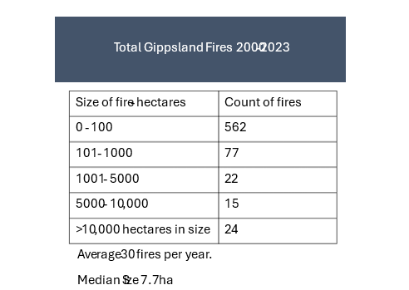

Bushfire Risk and Impact in Victoria: Drivers, Patterns, and Historical Context

Introduction
Bushfire risk in Victoria is shaped by where people live, how fuels accumulate, and the state’s climate and weather patterns. Victoria is one of the most fire-prone regions in the world, and its fire history since colonisation shows repeated, devastating events driven by the same underlying factors: flammable vegetation, extreme weather, and long dry periods.
Bushfires are a defining feature of Victoria’s environment. The state’s climate, vegetation, and terrain create conditions where fires ignite easily, spread rapidly, and can reach extreme intensity. Since colonisation, Victoria has experienced some of Australia’s most destructive bushfires, including Black Thursday (1851), Black Friday (1939), Ash Wednesday (1983), Black Saturday (2009), and the Black Summer fires (2019–20).

Understanding the risk factors—location, fuel accumulation, climate, drought, and weather—is essential for reducing impacts on communities, ecosystems, and infrastructure.

Bushfire Risk Factors in Victoria

Where You Live: Proximity to Forests and Fire-Prone Landscapes
Victoria’s landscapes include grasslands, dry sclerophyll forests, mountain ranges, and coastal heathlands. These environments contain vegetation that burns readily and intensely, especially eucalypt forests rich in volatile oils and stringybark litter.
Key location-based risk factors include:
- Living near or within forests: Forests produce large embers (from ribbon-bark and stringybark species) that can travel ahead of the fire front, igniting homes and vegetation kilometres away.
- Grassland–forest interfaces: Western Victoria’s grasslands ignite easily during dry spells, while eastern forests can produce massive fires when drought aligns with high temperatures.
- Mountainous terrain: Steep slopes accelerate fire spread and make suppression difficult.
These factors mean that communities in forested and foothill regions—such as Gippsland, the Dandenongs, Otways, and alpine valleys—face elevated risk.

Fuel Accumulation and Arrangement
Fuel load is one of the strongest predictors of fire severity. Victoria’s forests accumulate large amounts of leaf litter, bark, branches, and understorey vegetation. When these fuels build up over years without low-intensity fire, they create conditions for high-intensity bushfires.
Key fuel-related risks:
- High fuel loads increase flame height, intensity, and ember production.
- Continuous fuel beds in eastern Victoria allow fires to run for long distances.
- Ladder fuels (shrubs, mid-storey vegetation) carry fire into tree canopies.
- Fuel accumulation from fire suppression: Modern suppression policies have reduced the frequency of natural and cultural burning, contributing to heavier fuel loads.
Post-event inquiries—including after Black Friday (1939) and Black Saturday (2009)—have repeatedly highlighted inadequate fuel reduction as a major risk factor.

Climate: Drought, Seasons, and Long-Term Trends
Victoria’s climate is becoming hotter and drier, especially during the cool season (April–October). This trend increases fire risk by drying fuels and extending the fire season.
Key climate drivers:
- Long-term warming: Average temperatures have risen since the 19th century.
- Drying climate: Reduced rainfall in winter and spring limits fuel moisture recovery.
- More frequent heatwaves: Heatwaves dry vegetation rapidly and create extreme fire danger.
- Drought cycles: Drought intensifies fuel dryness and increases ignition likelihood.
These climatic shifts mean Victoria now experiences more frequent and intense fire weather conditions.

Weather: The Immediate Driver of Fire Behaviour
Weather determines when fires ignite and how they behave. Victoria’s most destructive fires occur during combinations of:
- High temperatures
- Low humidity
- Strong winds
- Dry lightning storms
Dry lightning is a major natural ignition source in Victoria, particularly in remote eastern regions.
Strong winds—often from the north—drive rapid fire spread, while cool changes can produce dangerous wind shifts that trap communities and firefighters, as seen on Black Saturday.

Impacts of Bushfires in Victoria

Human and Community Impacts
Major bushfires have caused:
- Loss of life (e.g., 173 deaths on Black Saturday)
- Destruction of homes and infrastructure
- Long-term mental health impacts
- Economic losses in the billions
- Displacement of communities and disruption of essential services

Environmental Impacts
Bushfires reshape ecosystems by:
- Causing canopy scorch and crown fire in forests
- Altering habitat structure
- Threatening species in unburnt refugia
- Triggering regeneration in fire-adapted vegetation
Eucalypt forests often recover strongly, but repeated high-severity fires can reduce biodiversity and alter ecosystem composition.

Infrastructure and Economic Impacts
Bushfires damage:
- Power networks
- Roads and bridges
- Water catchments
- Forestry and agricultural assets
Recovery can take years, especially in remote regions.

Victoria’s Fire History Since Colonisation
Victoria’s recorded fire history includes several landmark events:

1851 – Black Thursday
Burned one-quarter of the colony, marking the first major documented bushfire disaster.

1939 – Black Friday
Killed 71 people and burned 2 million hectares, prompting major changes in forest and fire management.

1983 – Ash Wednesday
Devastated communities across Victoria and South Australia, highlighting vulnerabilities in peri-urban and forest-edge settlements.

2009 – Black Saturday
One of the worst bushfire disasters globally:
- 450,000 hectares burned
- 2,000+ homes destroyed
- 173 deaths
- Extreme fire weather and heavy fuel loads contributed to catastrophic conditions

2019–20 – Black Summer
Burned 1.5 million hectares in Victoria, demonstrating how climate extremes and fuel accumulation can produce megafires even with modern suppression capacity.
Across all these events, the same themes recur: extreme weather, heavy fuels, and vulnerable communities located near forests.

Conclusion
Bushfire risk in Victoria arises from the interaction of location, fuel, climate, and weather. The state’s fire history since colonisation shows repeated catastrophic events driven by these factors. As Victoria continues to warm and dry, bushfire risk is expected to increase, making proactive fuel management, community preparedness, and climate adaptation essential.
Understanding these drivers is critical for building resilient communities and landscapes in one of the world’s most fire-prone regions.

Fire is useful
Our third contention is that fire is useful, that active use of fire in management of our forests is important for their future health.
- Fire has cultural significance
- First Nations have been using fire for 60,000 years
- Fire provides warmth and stimulates growth of preferred species
- Fire can reduce fuel loads and reduce risk or danger
- Fire can promote or protect certain ecosystems
Questions
- What is your view regarding the use of fire in our forests
- How can we promote and support the use of fire for cultural purposes by first nations people
- How impactful is planned burning and what is the right regime
- How can we use fire for the benefit of ecosystems
- Are there other tools than fire to achieve these ends

There are three main aspects to the use of fire
- Traditional owner use of fire
- Fire for ecological benefit
- Fire for risk reduction (fuel management)

- Traditional Owner Use of Fire in Gippsland: History, Practice, and Contemporary Significance
Fire has shaped Gippsland’s landscapes for thousands of years. Across the region — from the foothill forests of the Gunaikurnai, to the coastal Country of the Bunurong, to the high-country forests of the Taungurung — Traditional Owners used fire with precision, cultural meaning, and ecological insight. These practices created healthy, diverse, and resilient forests long before colonisation.
Although colonial disruption interrupted cultural fire regimes, historical accounts and contemporary revitalisation efforts show the depth of knowledge held by Gippsland’s First Peoples and the importance of restoring cultural fire to Country today.
Fire is central to cultural identity, law, and story across Gippsland’s Nations.

Gunaikurnai
For Gunaikurnai people, fire is woven through creation stories, seasonal knowledge, and the responsibilities of caring for Country. Fire supported movement through dense forest, maintained open pathways, and protected camps. It was also used in ceremony and in practices that strengthened kinship and connection to place.

Bunurong
On Bunurong Country — stretching across the coastal and foothill forests of South Gippsland — fire shaped the mosaic of grasslands, woodlands, and coastal heath. Burning supported food plants, encouraged fresh growth for animals, and maintained access routes along the coast and inland.

Taungurung
In the high-country forests and river valleys of the Taungurung, fire was used to manage understorey vegetation, support hunting, and maintain open forest structure. Burning was part of a broader cultural system that linked people, water, plants, and animals.
Across all Nations, fire was not simply a tool — it was part of a cultural and ecological system that connected people to Country and ensured its long-term health.

Historical Observations of Aboriginal Fire Use in Gippsland
Early colonial records, though incomplete and often biased, provide valuable insights into how Gippsland’s Traditional Owners used fire.
Although colonisation severely disrupted Aboriginal fire regimes, early colonial records provide valuable insights into how fire was used across Victoria. These records — journals, newspapers, and government documents — reveal a consistent pattern of purposeful, skilled burning.
Nineteenth-century observers noted that Aboriginal people regularly burned old grass, leaves, and fallen branches to promote new growth. This supported grazing animals and maintained productive ecosystems:
“It was their custom to burn off the old grass and leaves and fallen branches in the forest, so as to allow of a free growth of young grass for the mammals that feed on grass … they were at least careful to see that harm was not done to vegetables that yielded food.” — Smyth (1878)
Burns were typically small, controlled, and patchy, often limited to one or two acres (less than one hectare). This mosaic pattern created diverse habitats and reduced the risk of large, intense fires.

Burning for Landscape Care
Observers across Victoria noted that Aboriginal people regularly burned old grass, leaves, and fallen branches to promote new growth. In Gippsland, this created open, park-like forests that early settlers frequently described.
Burns were:
- Small and cool
- Patchy and mosaic-like
- Timed to seasonal conditions
- Designed to protect key food plants and cultural resources
These patterns are consistent with Gunaikurnai, Bunurong, and Taungurung oral histories that describe fire as a tool for maintaining balance across Country.

Burning for Hunting and Food
Fire supported hunting by:
- Flushing out small animals
- Encouraging fresh growth for grazing species
- Maintaining open forest floors for tracking
Historical accounts describe coordinated burns where people positioned themselves around a fire to catch emerging animals — demonstrating skill, planning, and group knowledge.
Fire was used to flush out small animals when larger game was scarce. People positioned themselves around a burn to catch lizards and other small animals as they emerged. This demonstrates both ecological knowledge and coordinated group practice.

Burning for Safety, Travel, and Communication
Across Gippsland’s varied terrain — from dense gullies to coastal scrub — fire was used to:
- Clear undergrowth for safe movement
- Maintain pathways between camps and seasonal grounds
- Protect camps from snakes and insects
- Signal across distances
These practices contributed to a landscape that was easier to navigate and less prone to large, destructive fires.

Aboriginal Expertise in Fire Management
Gippsland’s Traditional Owners were recognised by early settlers for their ability to read weather, vegetation, and fire behaviour. Historical accounts describe Aboriginal people:
- Teaching colonists how to control fire
- Assisting in fighting large fires
- Demonstrating techniques for safe burning
This expertise reflects thousands of years of observation, practice, and cultural responsibility.

Disruption and Loss of Knowledge
Colonisation caused profound disruption across Gippsland:
- Forced removal from Country
- Suppression of cultural practices
- Loss of access to traditional burning grounds
- Fragmentation of intergenerational knowledge
Despite this, cultural fire knowledge persisted in stories, memories, and practices maintained by Elders and community leaders.
Revitalisation of Cultural Burning in Gippsland
Over recent decades, Gunaikurnai, Bunurong, Taungurung, and other Gippsland Nations have led a resurgence in cultural burning. This revitalisation is supported by:
- Joint management arrangements
- Partnerships with agencies
- Community-led fire programs
- Renewed interest in cultural land management
Modern cultural burning in Gippsland emphasises:
- Cool, low-intensity burns
- Small, carefully placed patches
- Protection of cultural sites and species
- Integration of science and traditional knowledge
- Community participation and learning
These principles align closely with historical accounts and contemporary ecological science.

Contemporary Significance for Gippsland’s Forests

Cultural fire offers vital insights for managing Gippsland’s forests in a changing climate.
Cultural burning has ecological benefit and can support:
- Healthy understorey structure
- Habitat diversity
- Regeneration of culturally significant plants
- Reduced fuel loads
- Resilience against large bushfires
Cultural burning has community benefits:
- Strengthens connection to Country
- Revitalises cultural practice
- Creates opportunities for youth and community learning
- Builds relationships between Traditional Owners, agencies, and local communities

Fire Risk Reduction
Cultural fire has a lot of different meanings to different people. At its core, it’s about how first nations adapted to fire, then used it to “look after country”. Now, in a landscape changed by the past 200 years of colonisation, first nations want to use fire to heal country and to heal people by getting them back on country. Firesticks burning can’t achieve, or turn back the changes since colonisation and the past 100 years of suppression of fires in a short timeframe.
Low intensity cool burning across small areas wasn’t intended to achieve the kind of fuel modification to prevent bad bushfire days in the current forest structure and community setting. There are however many lessons to learn from their intimate knowledge of fire and its application.
Historical evidence suggests Aboriginal fire regimes helped prevent large, intense fires — this may be a more a reflection of non-suppression of natural fire (lightning) than active burning.

Conclusion
Traditional Owner use of fire in Gippsland reflects a sophisticated, culturally grounded, and ecologically informed system of land management. Gunaikurnai, Bunurong, Taungurung, and other Nations shaped the region’s forests through generations of careful, purposeful burning. Today, cultural fire is being revitalised across Gippsland, offering essential knowledge for forest resilience, community wellbeing, and climate-adapted land management.
Healthy forests, healthy communities, and strong cultural connections — cultural fire sits at the heart of all three.

- Fire for Ecological Benefit: Principles, Science, and Victorian Examples
Fire is a natural and essential ecological process in many Victorian landscapes. From the foothill forests of Gippsland to the box-ironbark woodlands of central Victoria and the coastal heathlands of the south-east, fire shapes biodiversity, regenerates vegetation, and maintains healthy ecosystems. When applied deliberately and skilfully, fire can support ecological resilience, reduce fuel hazards, and restore cultural and environmental values.

Fire as an Ecological Process
Many Victorian ecosystems evolved with fire. Over thousands of years, fire influenced:
- Vegetation structure
- Species composition
- Habitat diversity
- Nutrient cycling
- Landscape patterns
In these systems, fire is not simply a disturbance — it is a driver of ecological health. The absence of fire can lead to:
- Dense understorey growth
- Declines in fire-dependent species
- Loss of open habitats
- Increased fuel loads
- Reduced biodiversity
Ecological burning aims to restore these natural processes in a controlled, safe, and scientifically informed way.

Principles of Ecological Burning
Ecological burning differs from hazard-reduction burning in its purpose and design. While hazard-reduction burning focuses on reducing fuel loads, ecological burning aims to achieve specific ecological outcomes.
Key principles include:

Right Fire, Right Place, Right Time
Ecological burns are tailored to:
- Vegetation type
- Season
- Moisture levels
- Species life cycles
- Cultural values

Patchiness and Mosaic Patterns
Small, patchy burns create:
- Habitat diversity
- Refuge areas for wildlife
- Varied vegetation age classes
- Reduced risk of large fires

Protecting Fire-Sensitive Species
Burns are planned to avoid:
- Rare plant populations
- Nesting sites
- Critical habitat features

Supporting Fire-Dependent Species
Some species require fire to:
- Germinate
- Flower
- Resprout
- Maintain open habitat
Ecological burning ensures these species receive the fire they need.

Victorian Examples of Ecological Burning

Gippsland Foothill Forests — Restoring Open Understorey
In Gippsland’s foothill forests, planned ecological burns have been used to:
- Reduce dense shrub layers
- Promote native grasses and herbs
- Improve habitat for wallabies, bandicoots, and small marsupials
- Support Traditional Owner cultural burning programs
These forests historically experienced frequent, low-intensity fire — both lightning-driven and cultural. Ecological burns help restore this structure, reducing the risk of high-intensity bushfires.

Box-Ironbark Forests — Supporting Fire-Dependent Flora
Central Victoria’s box-ironbark forests contain species that rely on fire for regeneration. Ecological burns have been used to:
- Stimulate flowering in species such as Xanthorrhoea australis (grass trees)
- Promote germination of fire-responsive shrubs
- Maintain open woodland structure
- Support habitat for woodland birds
These burns are typically small, cool, and carefully timed to avoid impacts on nesting seasons.

Coastal Heathlands — Maintaining Biodiversity
Coastal heathlands in south-east Victoria are among the most fire-dependent ecosystems in the state. Without fire, heathlands become overgrown and lose species diversity.
Ecological burns in these areas have:
- Encouraged regeneration of heath species
- Supported populations of small mammals and reptiles
- Maintained open, low vegetation structure
- Reduced fuel loads in highly flammable landscapes
These burns often use narrow strips or small patches to maintain habitat complexity.

Alpine and Sub-Alpine Areas — Protecting Snow Gum Woodlands
In the Victorian Alps, fire plays a complex role. Snow gums can resprout after fire, but repeated high-severity fires can kill them. Ecological burning in alpine areas focuses on:
- Maintaining grassy plains
- Protecting snow gum regeneration
- Reducing woody encroachment
- Supporting alpine herb fields
Burns are extremely small and low-intensity due to sensitive alpine soils and vegetation.

Grasslands and Plains — Preventing Woody Encroachment
Victoria’s native grasslands evolved with frequent fire. Without fire, woody species invade, reducing grassland biodiversity. A major program to reclaim grasslands from woody species is occurring at Wilsons Prom.
Ecological burns in grasslands:
- Promote native grasses
- Support species such as the Eastern Barred Bandicoot
- Reduce invasive weeds
- Maintain open habitat for ground-nesting birds
These burns are often conducted in late summer or early autumn when grasses are dry enough to carry fire but conditions remain safe.
Cultural Burning and Ecological Outcomes
Traditional Owner cultural burning is increasingly recognised as a vital ecological tool. Cultural burns are:
- Cool
- Small
- Patchy
- Frequent
- Designed to protect cultural values
In many cases, cultural burning achieves ecological outcomes more effectively than conventional planned burning. Examples include:
- Protecting scar trees and cultural sites
- Maintaining open forest floors
- Supporting native grasses
- Reducing fuel without damaging canopy trees
Partnerships with Gunaikurnai, Bunurong, Taungurung, and other Nations are expanding the use of cultural fire across Victoria.
Benefits of Ecological Burning

Biodiversity
Ecological burning supports:
- Fire-dependent plants
- Habitat diversity
- Healthy understorey structure
- Species that rely on open ground

Forest and Landscape Resilience
Burning reduces:
- Fuel loads
- Risk of high-severity fires
- Dense understorey growth
It also improves:
- Regeneration
- Soil health
- Landscape connectivity

Cultural and Community Benefits
Ecological burning:
- Supports cultural revitalisation
- Builds partnerships between agencies and Traditional Owners
- Creates opportunities for community involvement
- Strengthens local knowledge

Conclusion
Fire, when used deliberately and skilfully, is one of the most powerful tools for ecological restoration in Victoria. Ecological burning supports biodiversity, maintains healthy forest structure, and reduces the risk of large, destructive fires. Victorian examples — from Gippsland’s foothill forests to coastal heathlands and alpine plains — show how fire can be used to restore ecological processes that have shaped these landscapes for thousands of years.
As climate change increases fire risk, ecological burning offers a pathway to healthier, more resilient forests and landscapes — and a future where science, culture, and community work together to care for Country.

- Using Fire to Reduce Bushfire Risk: Principles, Evidence, and Victorian Practice
Fire is one of the most widely used tools for reducing bushfire risk in Victoria. When applied deliberately, safely, and with clear objectives, planned burning can reduce fuel hazards, slow the spread of bushfires, and create safer conditions for communities and firefighters. However, its effectiveness varies significantly across ecosystems, seasons, and weather conditions. This paper outlines how fire is used to reduce bushfire risk, the science behind fuel reduction, and Victorian examples that illustrate both the strengths and limitations of this approach.

Why Fuel Matters
Bushfire behaviour is shaped by three main factors:
- Weather
- Topography
- Fuel
Weather is the dominant driver during extreme conditions, but fuel levels strongly influence:
- How quickly a fire spreads
- How intensely it burns
- How difficult it is to suppress
- How much ember attack occurs
Reducing fuel — especially near communities — can lower the likelihood that a fire becomes uncontrollable under moderate conditions and can improve suppression opportunities under severe conditions.

How Planned Burning Reduces Risk
Planned burning reduces bushfire risk by:
- Removing fine fuels (leaves, twigs, bark, grasses) that ignite easily
- Breaking up fuel continuity, slowing fire spread
- Creating lower-fuel zones that can assist suppression
- Reducing flame height and intensity
- Lowering ember production in some forest types
These effects are strongest in the first 1–5 years after burning, depending on vegetation type and regrowth patterns.

Types of Risk-Reduction Burning

Asset-Protection Burns
Conducted close to towns, settlements, and critical infrastructure. Purpose:
- Reduce flame height
- Lower ember attack
- Provide safer conditions for firefighters
- Protect homes and lives
These burns are generally the most effective and consistently supported by evidence.

Strategic Landscape Burns
Conducted in forested areas away from towns. Purpose:
- Slow the spread of large fires
- Create opportunities for suppression
- Protect catchments, roads, and evacuation routes
Effectiveness varies widely depending on forest type, weather, and burn history.

Cultural Burning
Led by Traditional Owners, cultural burning is typically:
- Cool
- Patchy
- Frequent
- Focused on specific cultural and ecological objectives
While not primarily designed for hazard reduction, cultural burning can reduce fine fuels and maintain open forest structure, contributing to lower bushfire risk in some landscapes.
Victorian Examples of Fire Used to Reduce Bushfire Risk

Gippsland Foothill Forests
In the foothill forests around Heyfield, Dargo, Briagolong, and the Latrobe Valley, planned burning has been used to:
- Reduce dense understorey
- Lower bark fuel loads
- Create strategic breaks along ridgelines
- Support safer conditions for suppression crews
These forests respond well to low-intensity burns, with fuel reduction benefits lasting several years.

Otway Ranges
The Otways have a long history of planned burning to protect coastal towns such as Lorne, Apollo Bay, and Anglesea. Burns in these areas:
- Reduce leaf litter and bark fuels
- Slow fire spread in messmate and stringybark forests
- Provide strategic buffers between forest and settlement
However, effectiveness declines rapidly in wetter forests where fuels accumulate quickly.

Box-Ironbark Forests (Central Victoria)
These forests carry high loads of fine fuels and bark. Planned burning:
- Reduces surface fuels
- Lowers spotting potential
- Creates safer conditions for firefighters
Fuel reduction benefits can last longer here due to slower regrowth compared with wetter forests.

Coastal Heathlands (South-East Victoria)
Heathlands are highly flammable and burn readily under severe conditions. Planned burning:
- Reduces shrub height
- Breaks up fuel continuity
- Protects coastal communities
These burns must be carefully timed to avoid ecological impacts.

Alpine Valleys
In alpine valleys and lower slopes, planned burning is used to:
- Maintain grassy understorey
- Reduce woody fuel build-up
- Protect access routes and remote communities
Burns are small and highly controlled due to sensitive vegetation.

Strengths and Limitations of Using Fire for Risk Reduction

Strengths
- Effective at reducing fine fuels
- Creates safer conditions for suppression
- Supports community protection when used near assets
- Can be integrated with cultural burning
- Cost-effective compared with mechanical treatments in many forest types

Limitations
- Effectiveness declines rapidly in wet forests
- Benefits are short-lived (often 1–5 years)
- Under extreme weather, fuel reduction has limited influence on fire behaviour
- Some ecosystems become more flammable after burning due to regrowth
- Planned burning windows are shrinking due to climate change
- Smoke impacts communities and health
These limitations highlight the need for a balanced, multi-tool approach to bushfire risk reduction.

Integrating Fire with Other Risk-Reduction Tools
Fire is most effective when combined with:
- Mechanical fuel reduction
- Strategic grazing in appropriate landscapes
- Fire-resistant building design
- Community preparedness
- Evacuation planning
- Traditional Owner cultural fire
- Landscape-scale forest management
No single tool can eliminate bushfire risk; fire is one part of a broader system.

The Role of Traditional Owners
Traditional Owner fire knowledge offers important insights for risk reduction:
- Cool, frequent burns maintain open forest floors
- Patchiness reduces fuel continuity
- Cultural objectives align with ecological resilience
- Burns are placed with deep knowledge of Country
Partnerships with Gunaikurnai, Bunurong, Taungurung, and other Nations are expanding the use of cultural fire across Victoria, strengthening both cultural and risk-reduction outcomes.

Conclusion
Fire is a powerful tool for reducing bushfire risk when used deliberately, safely, and in the right places. In Victoria, planned burning plays a critical role in protecting communities, supporting suppression, and maintaining safer landscapes. Its effectiveness varies across ecosystems and weather conditions, and it is most reliable when applied close to assets and integrated with other risk-reduction strategies.
As climate change intensifies fire seasons, Victoria’s approach to risk reduction will increasingly rely on:
- Strategic, evidence-based planned burning
- Cultural fire led by Traditional Owners
- Multi-tool landscape management
- Strong community partnerships
Fire will remain essential — not as a standalone solution, but as a key part of a resilient, adaptive bushfire management system.

Fire is changing
Our last proposition is that fire is changing, fires are getting more frequent and more intense, the risk to communities is consequently increasing, and we need to keep up.
- We are experiencing larger and more intense fires
- Current fire response is not keeping up with increasing risk
- We have new people living in or close to the bush (tree change)
- Volunteerism is declining
- There are new ways of doing things
Questions
- What is your reaction to this proposition
- What is your experience of the past 20 years
- What can we do better or different
- How can individuals reduce their risk (help themselves)
- How do we use local knowledge
- How can we keep the public informed and what do they need to know

Increased Fire Behaviour in Victoria: Trends, Drivers, and Implications
Over the past two decades, Victoria has experienced a marked increase in bushfire activity, severity, and complexity. Major events — including the 2006–07 Great Divide fires, the 2009 Black Saturday fires, the 2014 East Gippsland fires, and the 2019–20 Black Summer fires — reflect a broader shift in fire behaviour across the state. Fires are burning hotter, faster, and at larger scales, with more frequent days of extreme fire danger and more challenging conditions for suppression.
This paper outlines the key trends in Victorian fire behaviour since the mid-2000s and examines the underlying drivers contributing to this change.

Evidence of Increased Fire Behaviour in Victoria

More Days of Extreme Fire Weather
Victoria has seen:
- A rise in Forest Fire Danger Index (FFDI) values
- More frequent Severe, Extreme, and Catastrophic fire danger days
- Longer fire seasons, beginning earlier in spring and extending later into autumn
These trends are consistent across Gippsland, the northeast, and the central highlands.

Larger, Faster-Moving Fires
Major fires in the past 20 years have shown:
- Rapid rates of spread
- Long-distance ember attack
- High-intensity crown fire in multiple forest types
- Increased spotting distances, sometimes exceeding 20–30 km in extreme conditions
The 2019–20 fires demonstrated how quickly large areas can burn under modern conditions, with multiple fires merging into landscape-scale events.

Increased Frequency of High-Severity Fire
High-severity fire — which causes canopy scorch or canopy consumption — has become more common in:
- Wet eucalypt forests
- Foothill forests
- Alpine valleys
- Coastal forests
These ecosystems historically experienced less frequent high-severity fire.

More Challenging Suppression Conditions
Fire agencies report:
- More days when direct attack is impossible
- Increased reliance on defensive strategies
- More frequent large-scale evacuations
- Higher risk to firefighters due to unpredictable fire behaviour
These operational observations align with scientific assessments of changing fire dynamics.

Drivers of Increased Fire Behaviour

Climate Change
Climate change is the most significant driver of increased fire behaviour in Victoria. Key effects include:

Hotter Temperatures
Victoria’s average temperatures have risen, increasing:
- Evaporation
- Fuel dryness
- Likelihood of extreme fire weather

Reduced Rainfall in Key Seasons
Spring and autumn rainfall has declined in many regions, reducing opportunities for fuel moisture recovery.

More Frequent Heatwaves
Heatwaves dry fuels rapidly and create conditions for fast-moving, high-intensity fires.

Longer Fire Seasons
Fire seasons now start earlier and finish later, increasing the window for severe fire events.
Together, these factors create conditions where fuels ignite more easily, burn more intensely, and support rapid fire spread.

Fuel Accumulation and Forest Condition
Changes in forest structure and fuel dynamics have contributed to increased fire behaviour.

Increased Fuel Loads
In many forest types, fuel loads have increased due to:
- Reduced frequency of low-intensity fire
- Declining forest health
- Increased leaf, bark, and branch fall during drought
- Regrowth from previous high-severity fires

Denser Understorey
Shrub and mid-storey density has increased in foothill forests, creating:
- Higher flame heights
- Greater ladder fuels
- More intense fire behaviour

Post-Fire Regrowth
High-severity fires produce dense regrowth that can be highly flammable for decades, especially in:
- Ash forests
- Alpine valleys
- Foothill forests
This creates a cycle where one severe fire increases the likelihood of another.

Landscape-Scale Fire Connectivity
Large areas of Victoria have experienced repeated fires in the past 20 years. This has created:
- Extensive areas of similar-aged regrowth
- Continuous fuel beds across multiple catchments
- Fewer natural breaks in vegetation
When combined with extreme weather, these landscapes support large, fast-moving fires that are difficult to contain.

Declining Forest Health
Forest health has declined in several regions due to:
- Drought
- Heat stress
- Insect outbreaks
- Disease
- Repeated fire
Stressed forests drop more leaves and branches, increasing surface and elevated fuels. Declining forest resilience also means forests recover more slowly, remaining vulnerable to further fire.

Lightning and Ignition Patterns
Lightning ignitions have increased in some parts of Victoria, particularly in:
- East Gippsland
- Alpine regions
- The high country
Dry lightning storms — once rare — are now more common, creating multiple simultaneous ignitions under severe conditions.

Human Settlement Patterns
More people now live in high-risk areas, increasing:
- Ignition sources
- Exposure to fire
- Complexity of suppression operations
This does not directly increase fire behaviour, but it increases the consequences of severe fire events.

Victorian Case Studies

Black Saturday (2009)
- Extreme fire weather driven by record temperatures and drought
- Long-distance ember attack
- Rapid fire spread through multiple forest types
- High-severity fire in wet forests not typically prone to crown fire

East Gippsland Fires (2019–20)
- How lightning storms can ignite dozens of fires simultaneously
- How drought-stressed forests burn at extreme intensity
- How fires can merge into landscape-scale events
- How suppression becomes impossible under extreme weather
These fires burned for months and crossed multiple catchments.

Alpine and Foothill Forests (2003–2020)
Repeated fires in alpine and foothill forests have created:
- Dense regrowth
- High fuel loads
- Increased fire connectivity
This cycle has contributed to more frequent high-severity fire.

Implications for Victoria

More Frequent Large Fires

Victoria is likely to continue experiencing large, complex fires that burn across multiple catchments.

Increased Risk to Communities
More extreme fire behaviour increases:
- Evacuation frequency
- Infrastructure damage
- Smoke impacts
- Economic disruption

Challenges for Fire Agencies
- Narrower windows for planned burning
- More days when suppression is impossible
- Higher risk to firefighters
- Greater reliance on defensive strategies

Need for Integrated Landscape Management
Victoria’s future fire management will require:
- Cultural burning
- Ecological burning
- Mechanical fuel reduction
- Forest health interventions
- Community preparedness
- Strategic land-use planning
No single tool can address the scale of change.

Conclusion
Fire behaviour in Victoria has increased significantly over the past 20 years. Climate change, fuel accumulation, forest condition, landscape connectivity, and ignition patterns have combined to create more frequent, more intense, and more complex fires. These trends are reshaping how Victoria prepares for, responds to, and recovers from bushfire.
Understanding these drivers is essential for building resilient landscapes and communities — and for shaping a future where fire is managed safely, collaboratively, and with respect for both science and culture.

Emerging trends

Introduction
Forest fire management is undergoing rapid transformation worldwide. Climate change, shifting forest conditions, expanding settlement patterns, and increasingly severe fire seasons have pushed agencies, communities, and governments to rethink how fire is used, how forests are managed, and how wildfires are controlled. Australia — particularly Victoria — sits at the forefront of this shift, experiencing some of the world’s most complex fire behaviour and contributing to global innovation.
This paper outlines the major emerging trends in forest fire management, both in Australia and internationally, focusing on how fire is used as a tool and how wildfires are controlled in an era of escalating risk.

Global Drivers of Change
Across fire-prone regions — Australia, North America, southern Europe, South America, and parts of Africa — similar forces are reshaping fire management:
- Hotter, drier conditions driven by climate change
- Longer fire seasons and overlapping hemispheric fire periods
- More frequent extreme fire behaviour
- Increasing lightning ignitions
- Expanding settlement into forested areas
- Declining forest health and fuel accumulation
- Greater social and economic impacts of fire
These pressures have accelerated innovation and forced a shift from reactive suppression to proactive, landscape-scale management.

Emerging Trends in the Use of Fire

The Rise of Cultural Burning
One of the most significant global trends is the resurgence of Indigenous fire knowledge.

Australia
Traditional Owners — including Gunaikurnai, Bunurong, Taungurung, Yorta Yorta, Noongar, and many others — are leading a return to:
- Cool, patchy burns
- Frequent, small-scale fire
- Burning for cultural values, biodiversity, and fuel reduction
- Fire placement based on deep knowledge of Country
Cultural burning is increasingly recognised as:
- Ecologically beneficial
- A tool for reducing fine fuels
- A way to maintain open forest structure
- A pathway for community resilience and cultural revitalisation

Global parallels
Indigenous fire stewardship is being revitalised in:
- California and the Pacific Northwest
- Canada (First Nations cultural fire programs)
- Brazil (Indigenous fire management in the Cerrado and Amazon edges)
- Southern Africa (San and Bantu fire knowledge)
These programs share common principles: cool fire, patchiness, cultural purpose, and ecological sensitivity.

Shift Toward Ecological Burning
Ecological burning is expanding as agencies recognise that fire is essential for forest health.

Key trends:
- Burning designed to support biodiversity
- Mosaic burns to create habitat diversity
- Fire used to maintain grasslands, heathlands, and open woodlands
- Burns timed to species life cycles
- Integration of ecological monitoring into burn planning

Victorian examples:
- Coastal heathland burns to maintain species richness
- Box-ironbark burns to stimulate grass tree flowering
- Foothill forest burns to reduce shrub density and support marsupial habitat
Globally, ecological burning is now standard practice in:
- US National Parks
- Canadian provincial parks
- South African fynbos reserves
- Mediterranean pine forests

Targeted Risk-Reduction Burning
While broad-scale burning is declining, targeted burning near assets is increasing.

Australia
Agencies now focus on:
- Burns within 1–3 km of towns
- Strategic ridgelines and access routes
- Burns designed to reduce ember attack
- Smaller, more precise burns rather than large-area targets

Internationally
Similar approaches are used in:
- California’s Wildland-Urban Interface (WUI)
- Portugal’s community protection zones
- Canada’s FireSmart programs
- Chile’s peri-urban fire buffers
The trend is clear: precision over area.

Emerging Trends in Wildfire Control

Increased Use of Aerial Firefighting
Aerial firefighting has expanded dramatically worldwide.

Trends:
- Large air tankers (LATs) and very large air tankers (VLATs)
- Night-time aerial operations
- Drone-based ignition and surveillance
- Real-time mapping from aircraft

Australia
Victoria, NSW, and WA now maintain:
- Year-round aviation fleets
- Night-rated helicopters
- Drone teams for ignition and reconnaissance

Global parallels
- The US operates the world’s largest aerial fleet
- Canada’s CL-415 water bombers are used internationally
- Europe has expanded shared aerial resources through the EU Civil Protection Mechanism
Aviation is now central to early attack and large-fire management.

Remote Sensing and Real-Time Fire Intelligence
Technology is transforming fire control.

Tools now widely used:
- Satellite-based hotspot detection (Himawari-8, MODIS, VIIRS)
- Real-time fire spread modelling
- AI-assisted prediction tools
- Thermal imaging from drones
- High-resolution mapping for suppression planning

Australia
Victoria’s Phoenix RapidFire modelling system is world-leading and increasingly used internationally.

Global parallels
- US Forest Service uses advanced predictive services
- Canada integrates satellite data into national fire intelligence
- Europe uses Copernicus Emergency Management Service
Fire control is becoming data-driven and predictive, not just reactive.

Strategic Suppression Rather Than Direct Attack
Extreme fire behaviour has forced a shift in suppression tactics.

Trends:
- More indirect attack (backburning, containment lines)
- Greater reliance on natural barriers
- Use of strategic fuel breaks
- Pre-positioning of crews and aircraft
- Defensive strategies during peak conditions

Australia
Black Saturday and Black Summer demonstrated that direct attack is often impossible under extreme conditions. Agencies now:
- Focus on early attack
- Withdraw during peak fire behaviour
- Re-engage when conditions moderate

Global parallels
- California and Canada use similar “withdraw and re-engage” strategies
- Mediterranean countries rely heavily on indirect attack due to steep terrain

Landscape-Scale Fire Management
A major global trend is managing fire at the landscape scale, not just at the fire edge.

Components:
- Multi-agency coordination
- Cross-tenure planning
- Regional fuel strategies
- Integrated forest management
- Long-term forest health interventions

Australia
Victoria’s Forest and Fire Management Strategy and NSW’s Regional Strategic Fire Plans reflect this shift.

Internationally
- US: “All Lands, All Hands” approach
- Canada: Landscape Fire Management Plans
- Europe: Integrated Fire Management (IFM) frameworks
The trend recognises that fire behaviour is shaped by whole landscapes, not individual fires.
Emerging Trends in Community and Governance

Community-Led Fire Management
Communities are increasingly involved in:
- Local fuel management
- Evacuation planning
- Fire-adapted community programs
- Volunteer cultural burning
- Citizen science monitoring
This trend is strong in Australia, the US, Canada, and southern Europe.

Integration of Traditional Owners into Governance
Governments are embedding Traditional Owners into:
- Joint management
- Fire planning
- Cultural fire programs
- Landscape-scale decision-making
This is one of the most significant governance shifts in Australia.

Recognition That Fire Cannot Be Eliminated
Globally, agencies now acknowledge:
- Fire is inevitable
- Suppression alone cannot prevent large fires
- Forests must be managed for resilience, not avoidance
- Communities must be prepared for fire as a recurring event
This marks a major philosophical shift in fire management.

Conclusion
Forest fire management is changing rapidly in Australia and worldwide. The emerging trends reflect a move toward proactive, integrated, culturally informed, and technologically advanced approaches. Fire is increasingly used as a tool for ecological health, cultural practice, and risk reduction, while wildfire control relies on advanced intelligence, strategic suppression, and landscape-scale planning.
The future of forest fire management will be shaped by:
- Climate change
- Forest condition
- Cultural leadership
- Technology
- Community involvement
In this new era, fire is not simply a threat — it is a force that must be understood, respected, and managed with skill, science, and cultural knowledge.

Creating a vision – future thinking
A key outcome of our discussion will be to undertake some future thinking.
In 20 years from now:
- what does fuel management look like,
- what does fire suppression look like,
- what is forest structure – what level of intervention is appropriate
- how are the community involved
We would like to take some of the themes and concepts presented here, and explore what a vision might look like, what it should consider.
It is unlikely this can be achieved in this one dialogue, and any consensus reached on wording but we want to explore what it may look like, and what it may include.
If we can articulate a desired state or outcome for aspects, it then allows us to explore what is stopping us, whats agreed, what isn’t and what pathway is needed to get there.

For example, if emerging trends are telling us:
- there is a rise in cultural burning
- there is a shift towards ecological burning
- fuel reduction burning is more targeted and risk based
- there is increasing use of aircraft in suppression
- more remote sensing and real time intelligence
- changing suppression tactics
- community led approaches to fire management
- acknowledgement fire can’t be eliminated
- using science and evidence to drive change
and recent enquiries tell us
- our climate is changing – so we need to change
- fuel management is not enough; it is a tool not a solution
- forests need active - what long-term care
- communities are central to bushfire resilience
What then do we want, is our vision about
Enabling and empowering First Nations burning, being more targeted in our burning practices and view burning as part of a broader risk approach, instilling a learning and adaptive approach and not relying on current practice in a changing world. Having communities who know and understand the risk and are empowered to take action to protect themselves and their communities. And what kind of forest do we want and how much intervention are we prepared to undertake. Investing in science and monitoring and evaluation to drive change.

If our dialogue helps us identify these aspects we can continue the conversation and successive dialogues breaking down each aspect and discussing
- what we agree upon, what we don’t
- the barriers to realising that ambition within the vision
- how it may be achieved – what our targets may be or our objectives to achieve it

Opportunities for dialogue
A key outcome of our discussion will be how do we keep the conversation going

- Our next dialogues or fire sub topics to explore
- Talking to Government
- Collaborative alliances
- Community led planning
- POD case study

Further reading
For further reading visit our website and our fire dialogue page

GFD get involved

Whats next
Register for our newsletter or become a member at https://gippslandforestdialogue.org.au/join-gfd/

Our strategic plan
See our strategic plan on our website….

