Sale Dinner Information
On the night preceding the dialogue at Knob Reserve we offer a chance for those arriving early to meet up for dinner.
We will use a local community space, with a private room, the Bond Street Event Space.
Finger food will be provided, and drinks can be purchased at the venue (licenced).
Cost for the night will be $25
Whilst the night is mostly informal and a chance to connect with others, we are fortunate to have a guest speaker, John Schauble

John Schauble has more than 40 years’ experience as a CFA firefighter, including eight as a brigade captain in the Dandenong Ranges east of Melbourne. For much of that time, he has also been a CFA community bushfire educator. As a journalist with The Age and the Sydney Morning Herald for more than 20 years, he wrote extensively about fire and is author of The Australian Bushfire Safety Guide (HarperCollins, 2004). In 2007, he joined the Victorian Public Service and worked at a senior level in fire and emergency management for over a decade, notably on the government response to the 2009 Victorian Bushfires Royal Commission. He was later one of the principal researchers and authors of the IGEM inquiry into the 2019-20 Victorian bushfires. John grew up in and has lived most of his life in the Dandenongs, more recently dividing his time between there and a family property in the Wonnangatta Valley in Gippsland. His farmhouse at Eaglevale was completely destroyed in the January 2026 bushfires.
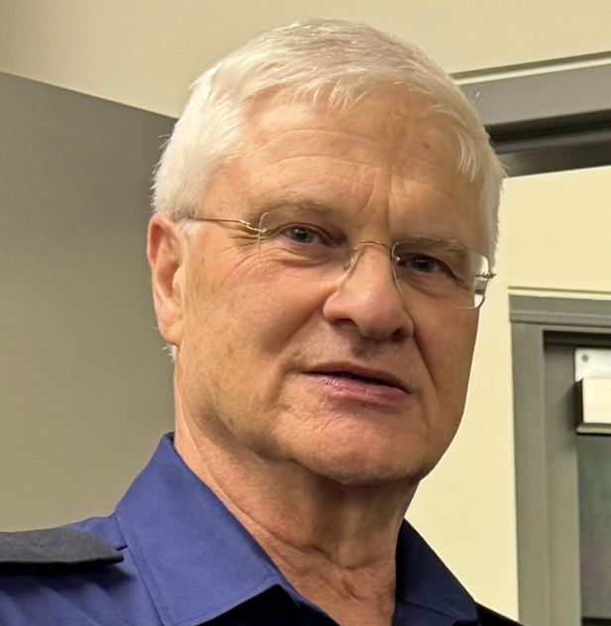

John will reflect both on his professional experiences in bushfire management and recent fires, but also his personal story protecting his own property at Eaglevale and the loss of that property earlier this year.

