Bairnsdale meeting point

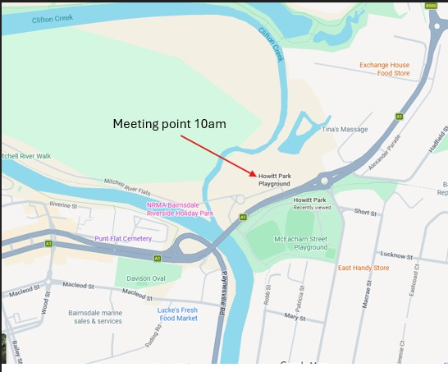

Trip map

This is the planned route including stops at GLaWAC, Tambo Upper Wards Rd Burn (treated in April, values including GBC present – see below), Old Man Hill Sarsfield (forest burnt hot in 2020, on interface), then finishing at Sarsfield Rec Centre. Google says it’s an hour on the road.

This may be subject to change as we get nearer the date, and confirm arrangements

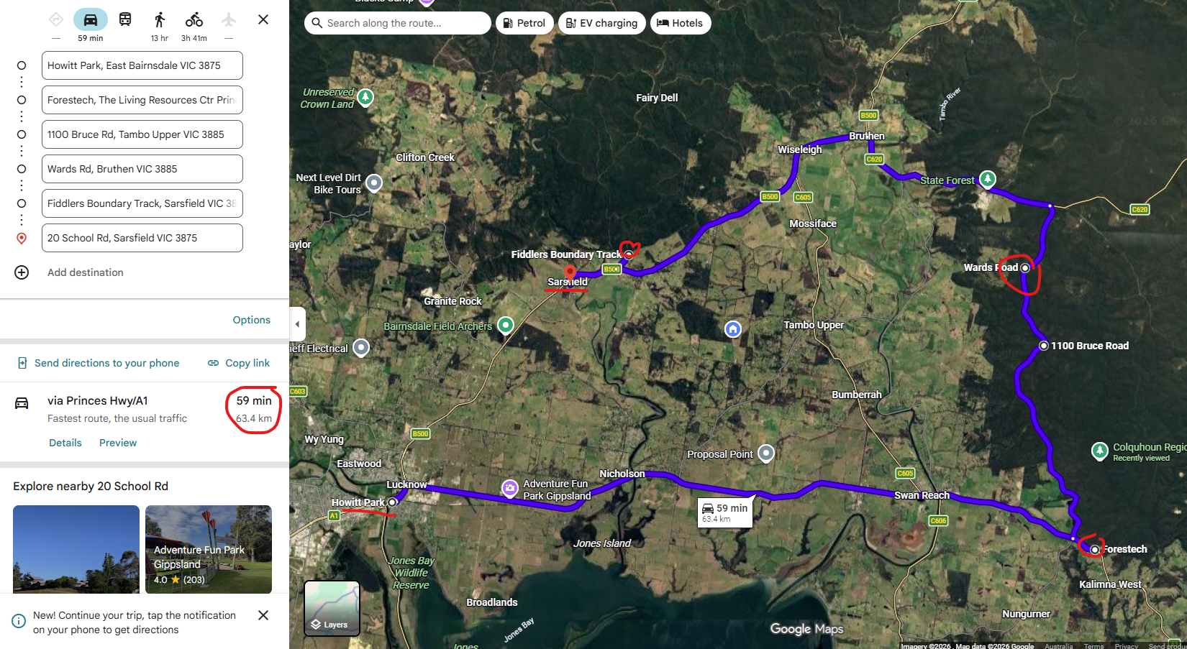

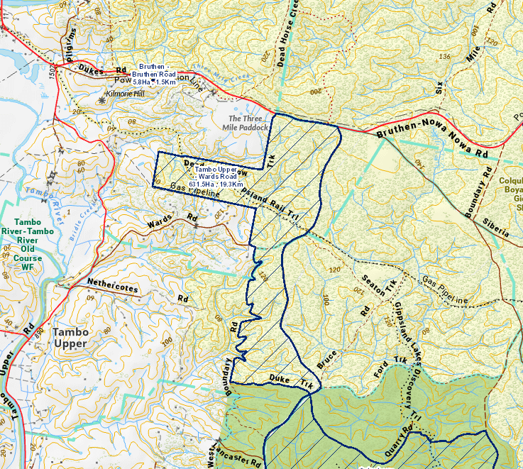

OFFICIAL

