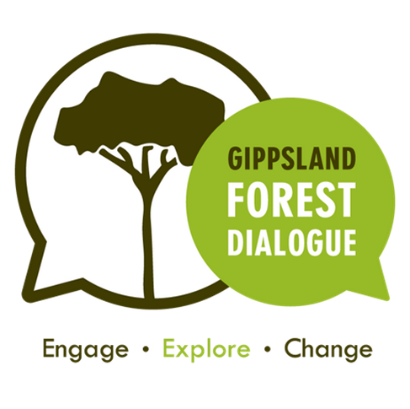**Scoping document**

Forest Recreation

Heyfield Wetland Centre

22nd – 23rd November

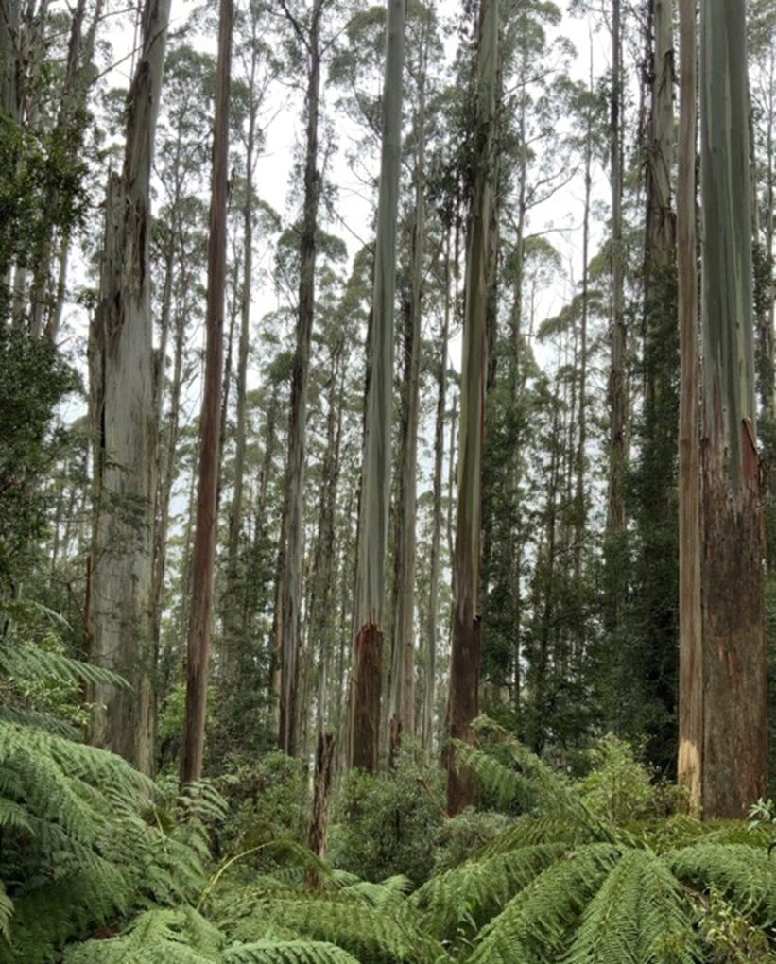

Introduction 3

Co-chairs 3

Where and when 4

The dialogue process 4

What you can expect 4

What we expect of you 5

Background 5

The Jindivick dialogue 5

The Great Outdoors taskforce 5

Forest management planning 5

Parks management 6

Emerging trends 6

Opportunities for dialogue 6

Theme 1: Local problems, local solutions 6

Discussion questions 6

Theme 2: Policy – transparency and evaluation 6

Discussion questions 6

Theme 3: Education 6

Discussion questions 6

Theme 4: Value – who benefits , who pays 6

Discussion questions 6

Theme 5: Forest behaviour – charter of common ground 7

Discussion questions 7

Dialogue agenda 7

Saturday 22nd November 7

Sunday 23rd November 7

Further reading 7

GFD get involved 7

Whats next 7

Our strategic plan 7

# Introduction

Welcome to the Heyfield recreation dialogue, the sixth event run by Gippsland Forest Dialogue over the past 3 years.

Each dialogue we conduct covers a theme of forest management relevant to Gippsland and the future of our forests.

Previous dialogues have considered themes such as plantations (Yarram), forest health (Orbost) and where to post timber harvesting in our forests (Kalimna).

In 2024 a discussion on forest recreation and the Great Outdoors taskforce was undertaken at Jindivick. It was agreed to continue this conversation and we will draw on the issues raised there to lead a dialogue on the challenges and opportunities confronting public access and enjoyment of our forests.

The dialogue will look at what this might mean to different stakeholders and communities, and work to find actionable recommendations to achieve balanced outcomes. The starting point will be 5 key topics identified at Jindivick but will explore other content.

The 5 key topics from Jindivick were:

* Local problems, local solutions – involving community
* Transparency and evaluation of Government policy
* Education
* Value of forest recreation – who benefits, who pays
* Forest behaviour – a charter of conduct including safety

## Co-chairs

Liz Clay

Liz has a long history of environmental advocacy and involvement in community. Hailing from Noojee, Liz has ridden many of the horse trails of Gippsland and has a strong connection to people across the region.

Dan Salzman

Dan grew up in Swifts Creek on a farm and has worked in timber industry transition and forest management with Government. He is a keen mountain bike rider and a passionate Gippslander.

## Where and when

The forest recreation dialogue will take place in and around Heyfield over 2 days (22nd and 23rd November). The Heyfield wetland centre will be our base with field trips to the surrounding forest and recreation sites.

This area is part of the traditional lands of the Gunai-Kurnai people and we pay our respects to their elders past and present.

# The dialogue process

The forest dialogue is an engagement approach developed at Yale University and practised in a number of countries around the world. It involves a process of engage, explore and change. Gippsland is the first Forest Dialogue group in Australia, formed 3 years ago and this is the 6th dialogue that has been conducted in that time.

## What you can expect

The purpose of the dialogue and the group is to build trust and connection across stakeholders and community members interested in the future of our forests. Our intent is to provide a safe and respectful space where people can come and share their thoughts and importantly listen to views of others.

The group is not a decision maker or an advocate for any specific view or postion. Whilst we look for opportunities for collaborative change, we do not force this.

Part of that safe place is that whilst we report on the conversation, but we do so in a way representing the various views but not specifically identifying individuals or their particular comments.

There is no guarantee of any specific outcome from a dialogue other than the building of relationships and learning you may take away for yourself or your work or interests.

## What we expect of you

We expect you to approach the dialogue consistent with this in mind.

To share your knowledge and perspectives

To listen to others and show them respect and encourage their voice

To be open and curious and willing to empathise with others

To respect the privacy of participants and the confidentiality of what is shared

# Background

Gippsland has much to offer……

Annual visitation

Worth to the economy

Key user groups and visitor profiles

Key sites

Emerging trends

Joint managed land

## The Jindivick dialogue

On Saturday 16 November, the Gippsland Forest Dialogue convened a scoping dialogue on the theme of recreation in Gippsland’s forests. It was attended by 25 people, mostly West Gippslanders.

A range of views and ideas were put forward by attendees, with discussion around the following:

* Gippsland residents highly value local forests but this is not reflected in Government priorities and investment in facilities
* Some areas are being negatively impacted by overuse. Balancing equity in access, providing for a range of users and uses and managing conflicting recreation users are contentious issues
* Victorian Government panels and taskforces are consulting with community about the future of their forests, but people feel disempowered, are suffering consultation fatigue and do not trust that their views will influence decisions
* Younger people are not being provided sufficient opportunities to spend time in and learn about the bush. This increases the risk of recreation behaviours that impact negatively on forests
* New approaches to managing and funding recreation opportunities in Gippsland’s forests are needed. Decentralised decision making and an increased community role will empower local knowledge, capacity and resources resulting in better outcomes for forests
* A Gippsland Forests Charter of Common Ground (an intergenerational agreement) could provide a statement of shared values and aspirations for forests and responsibilities for care and reciprocity

Some key issues noted were:

* Over utilisation of popular areas
* Minimal and seemingly cursory engagement around forest policy with no follow up
* Centralised decision making with lack of transparency and accountability, with locals left to liver with the outcomes
* Lack of education and awareness of regulations
* Challenges of accommodating different user groups and understanding good practice
* Scarcity of enforcement and people on the ground to manage forest assets
* Lack of leadership from government and desire for an opportunity for greater community voice and participation in forest management
* Fewer children growing up with knowledge and experience of forests

Potential opportunities for change included:

* Increased capacity for local. On ground managers, including joint management with Traditional Owners
* A stewardship model with different groups taking on different roles
* Support for citizen science activities to monitor impact and change
* Empower local communities to advocate for their forests and appropriate use

There was concern regarding a basic loss of connection with forests, especially the younger generation. Ideas discussed included:

* Increasing local knowledge in management and policy, especially indigenous knowledge
* Broader education around appropriate uses in different areas
* More awareness of forest natural assets – shared via info centres, guided walks, websites and social media
* Creation of a forest discovery centre with info on tracks and trails, safety, guidelines, heritage etc
* Forest experiental education – outdoor ed programs
* Holiday programs for kids, to explore pathways of using forests for therapy/wellbeing programs
* Welcome new residents with community champions to build resilience and connection to towns and improve disaster preparation

## The Great Outdoors taskforce

Summarise the process and taskfor4ce

## Forest management planning

Outline the recent fmp process and findings

## Parks management

Mmmm

# Emerging trends

Kkkkkkk

# Opportunities for dialogue

Nnnn

## Theme 1: Local problems, local solutions

mm

### Discussion questions

Mmmm

## Theme 2: Policy – transparency and evaluation

Mm

### Discussion questions

Mm

## Theme 3: Education

Mmm

### Discussion questions

Mm

## Theme 4: Value – who benefits , who pays

Mmm

### Discussion questions

Mm

## Theme 5: Forest behaviour – charter of common ground

Mm

### Discussion questions

# Dialogue agenda

## Saturday 22nd November

9:30 Meet at Heyfield Wetland Centre

Morning tea on arrival

10.00 Dialogue commence

Co chairs and host introduction: Chris McEvoy, Liz Clay, Dan Salzman

Acknowledgement of country: Chris McEvoy

Welcome to country: Cheryl Drayton

Gippsland Forest Dialogue Background: Rod Keenan

Participant introductions – who, why and what you expect

11.00 Heyfield Wetland Centre – Forest Bathing (Sue)

11:30 Public land recreation context (TBA – Mike Dower?)

Traditional Owner perspective (Cheryl Drayton)

User group perspective (Nick King MTB, 4wd?)

12:30 Lunch

1:00 Plenary session

Jindivick dialogue – discuss outcomes

Key themes to explore

Participant perceptions

2:00 Field trip (Mike Dower)

Blores Hill, Ben Crouchen, Knob Reserve,

3:30 Return to wetlands – afternoon tea

4:00 Day close

## Sunday 23rd November

9:00 Heyfield Wetland Centre

9:15 Commence

Review day 1 – Co chairs

Participant reflections

10:00 Theme based tables

10:45 Morning tea

11:00 Wetland walk with committee chair

11:30 Themed workshops

12:30 Lunch

1:00 Report back / review

2:00 Reflection

On the event

On your participation

3:00 Dialogue close

# Further reading

Mmmm

# GFD get involved

## Whats next

O

## Our strategic plan

ddd